POP IN GAMES

PopInGames is an advertising technology company which provides dynamic, targeted and automated native in-game advertising for the global video games industry across multiple platforms. Its proprietary technology is capable of inserting advertisements within video games, VR Experiences, Metaverse.  PopInGames's customers are games publishers and developers (on the supply side), and advertising agencies, brands and media-buying platforms (on the demand side).

Below you will find screen shots from UI containing; Developers, Advertisers and Admin

DEVELOPERS

Developers will be using Dashboard; to download plugin ( currently UNITY but soon UNREAL will be added), watch manuel & download manuel pdf, add games, delete games, block brands, select & block regions, add new spot, add video spot, give brief description on their games ( genre, targeted group, regions etc…), follow games ad performence in means of #view&duration per game, #view&duration per ad spot, #view&duration per campaign, #view&duration per brand, total income per game: ad spot-campaign-brand. Same items with per click.

#of games & ad spots, #of campaign per game

total income, total withdrawal, total cash remaining in wallet. Export reports in pdf&excell&doc

Suggest new advertisers & brands ( with communication details )

Setup user details of their company ( admin – game specific)

<https://popingamesui.softrobotics.lt/developer/dashboard>

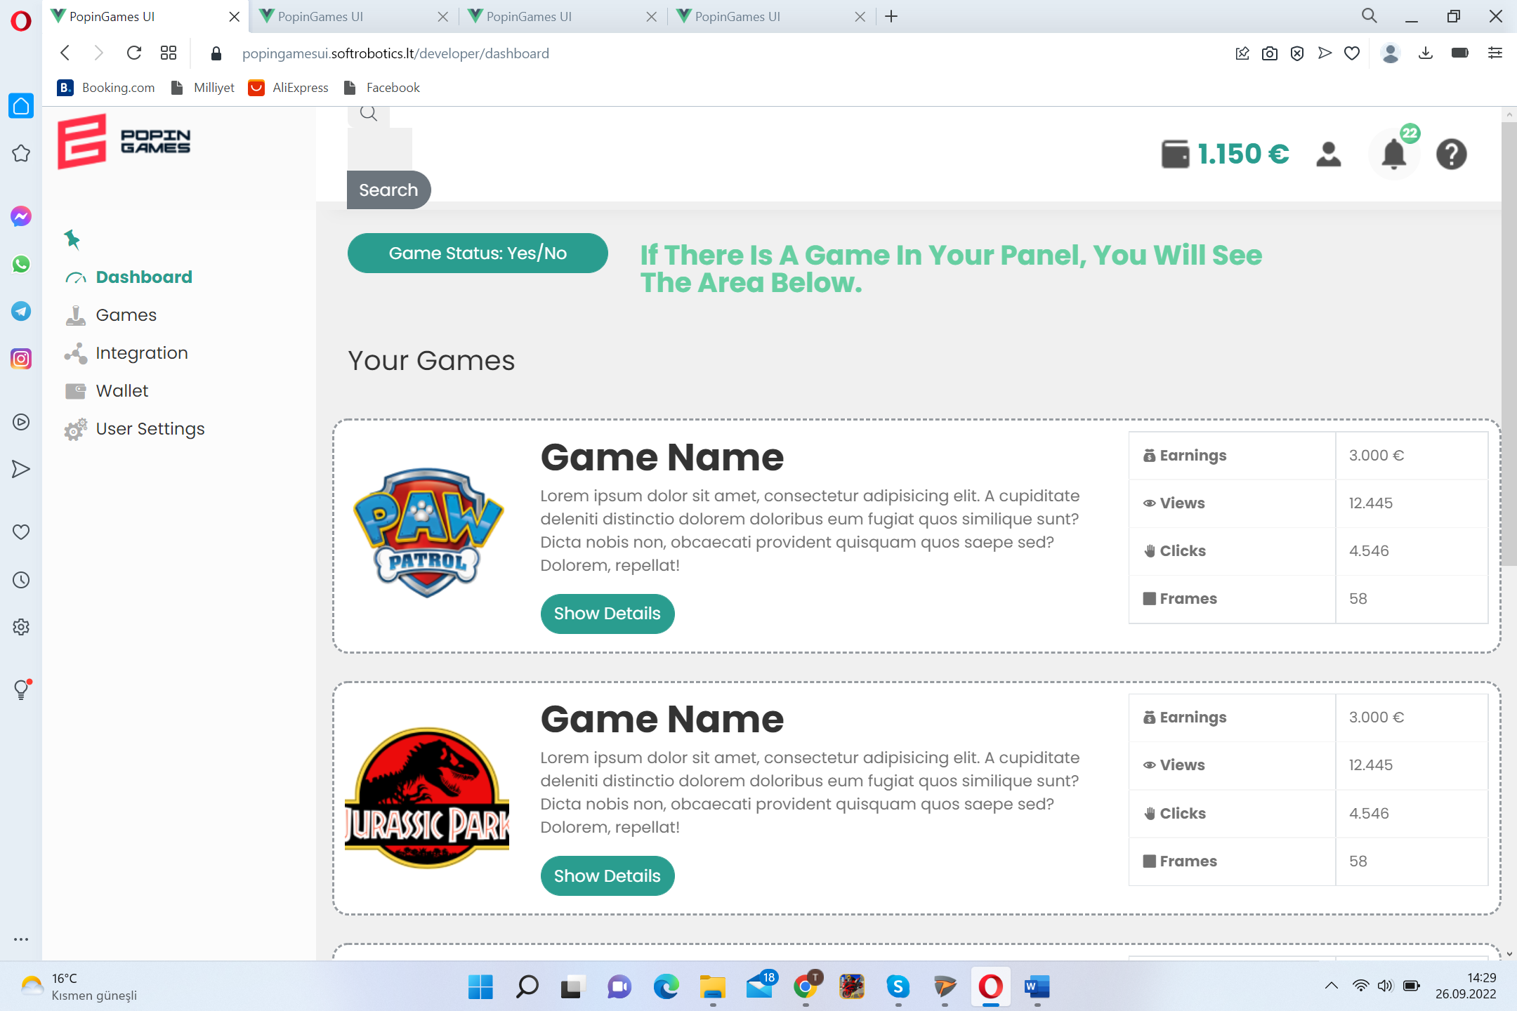 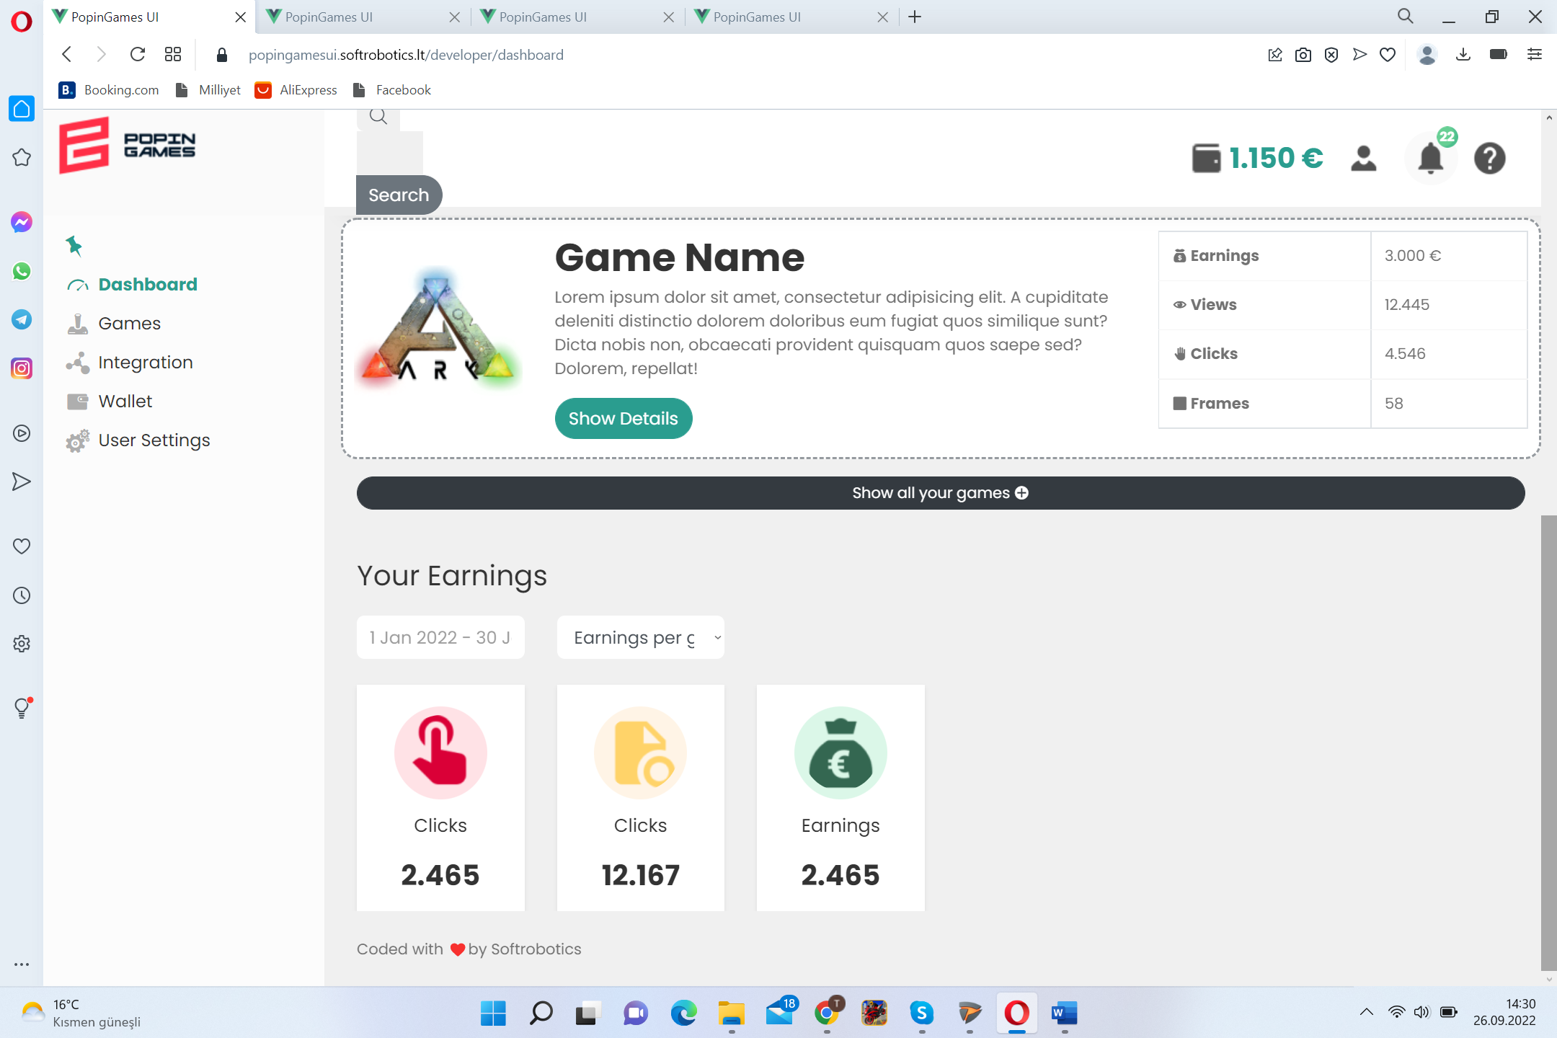

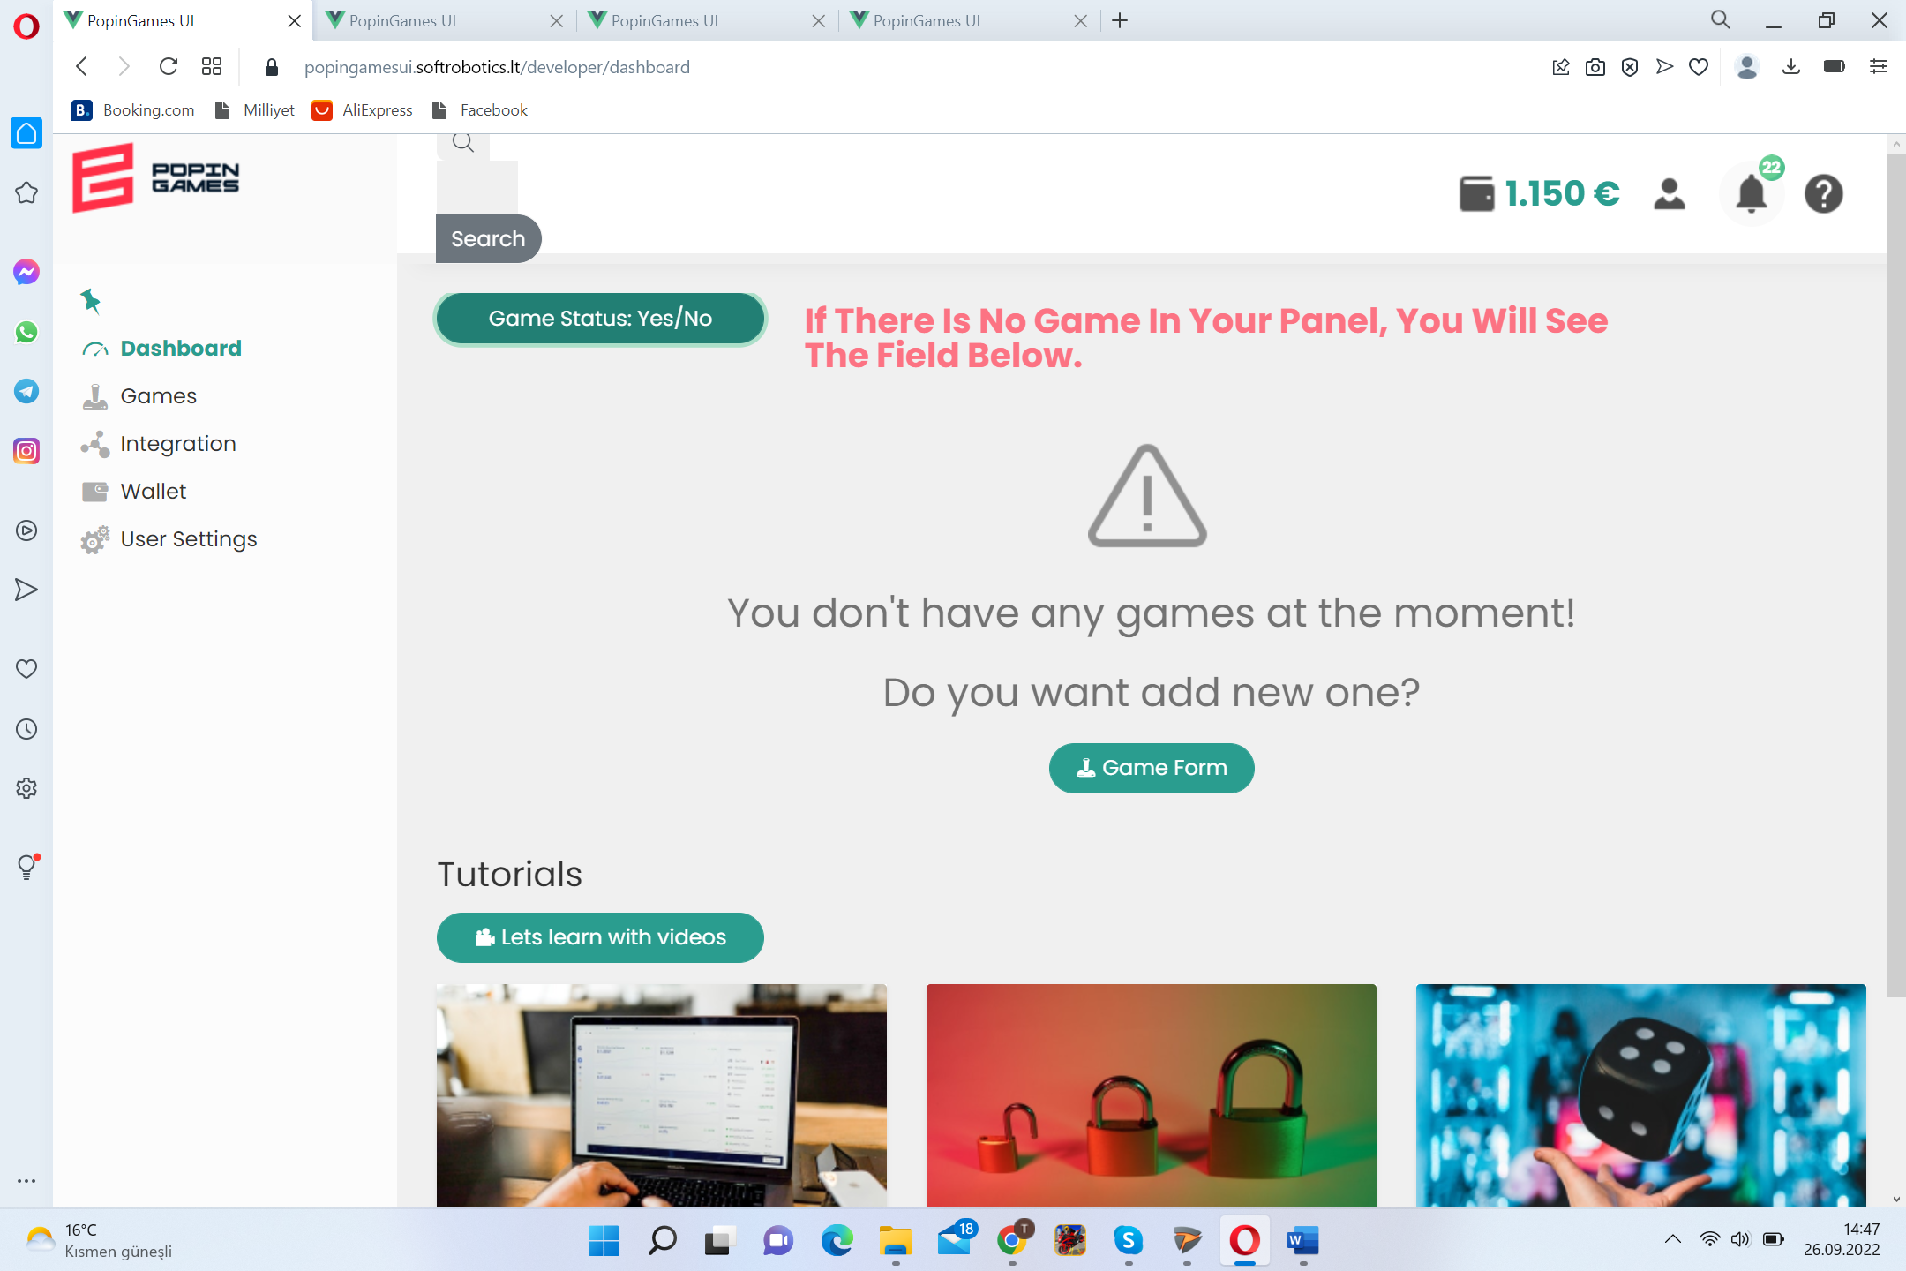 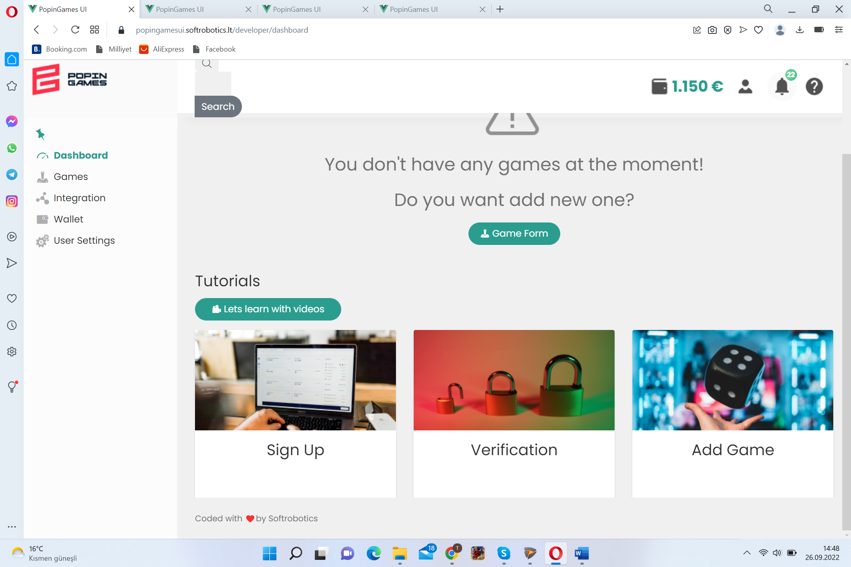

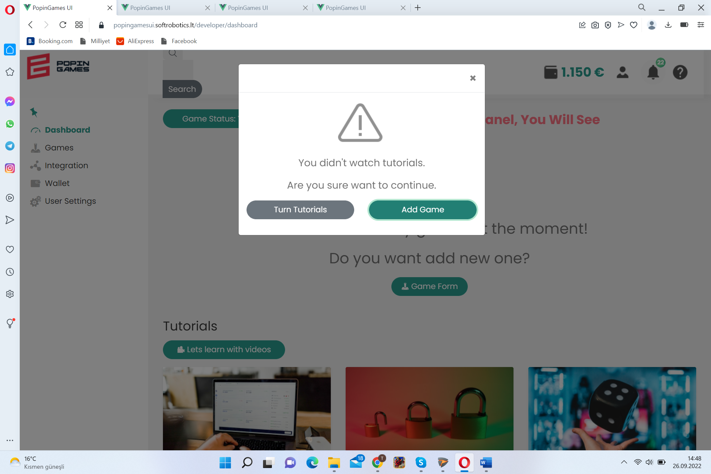

<https://popingamesui.softrobotics.lt/developer/games>

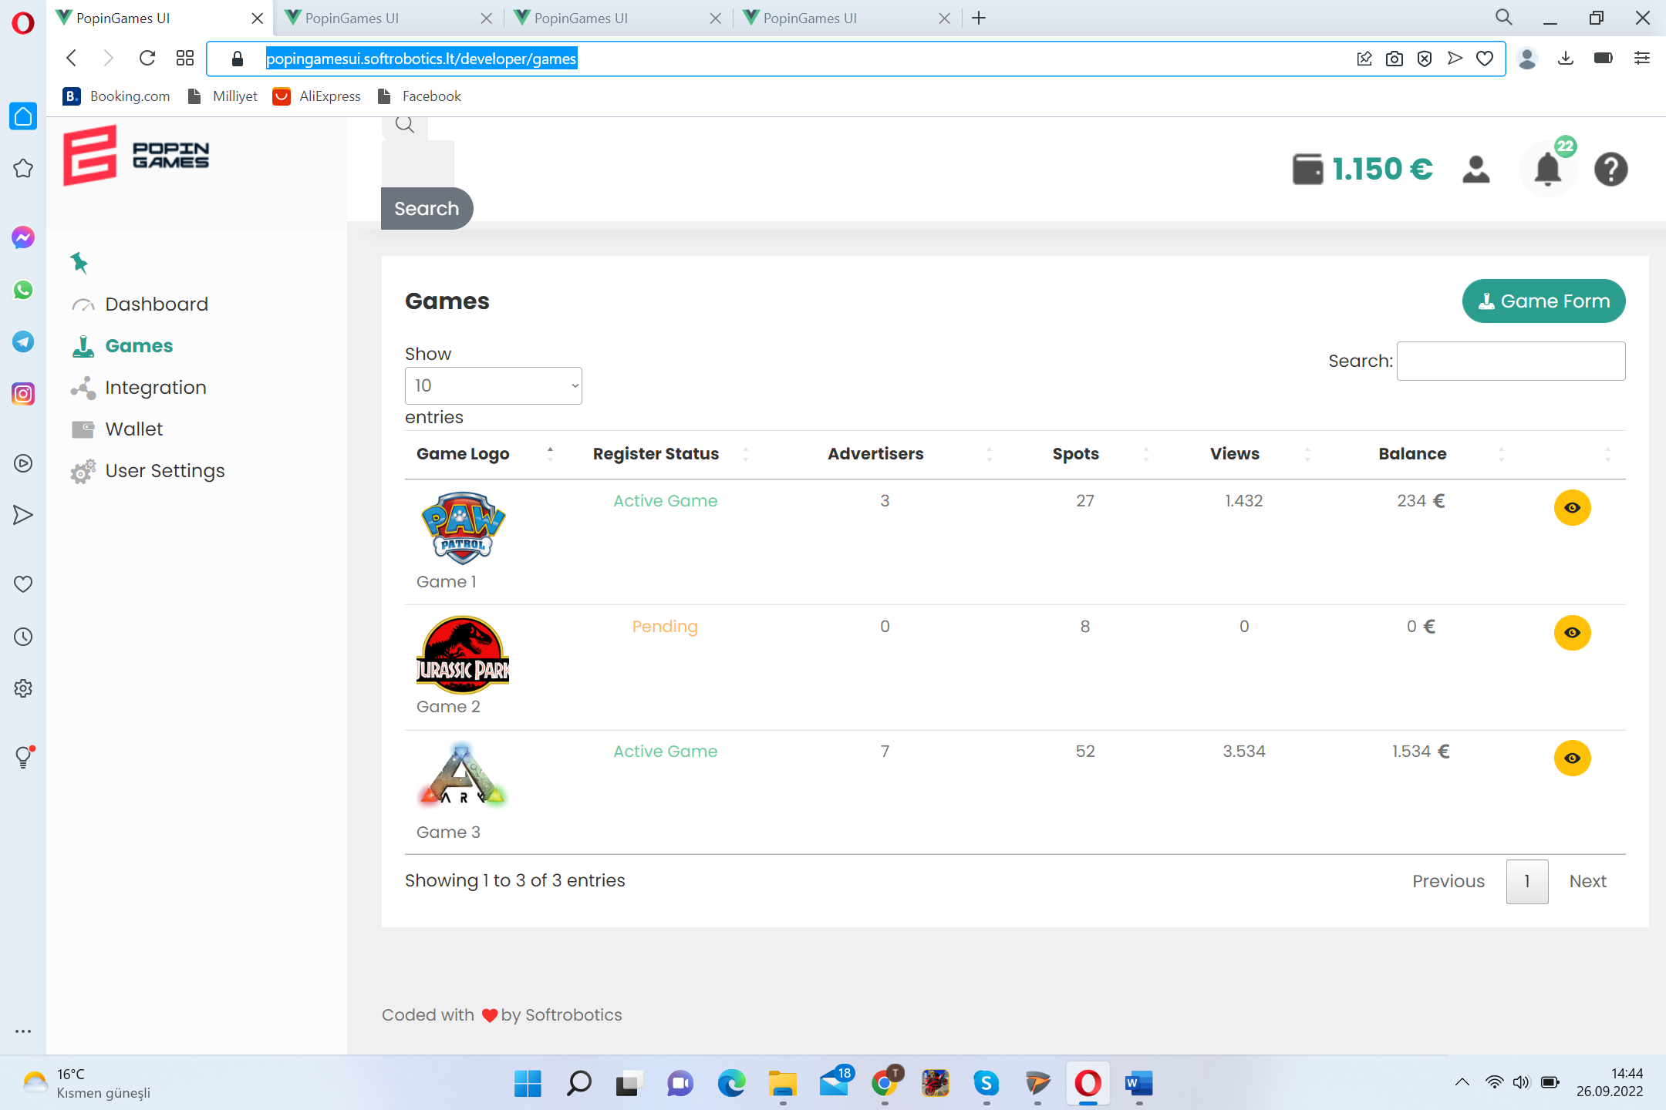

<https://popingamesui.softrobotics.lt/developer/integration>

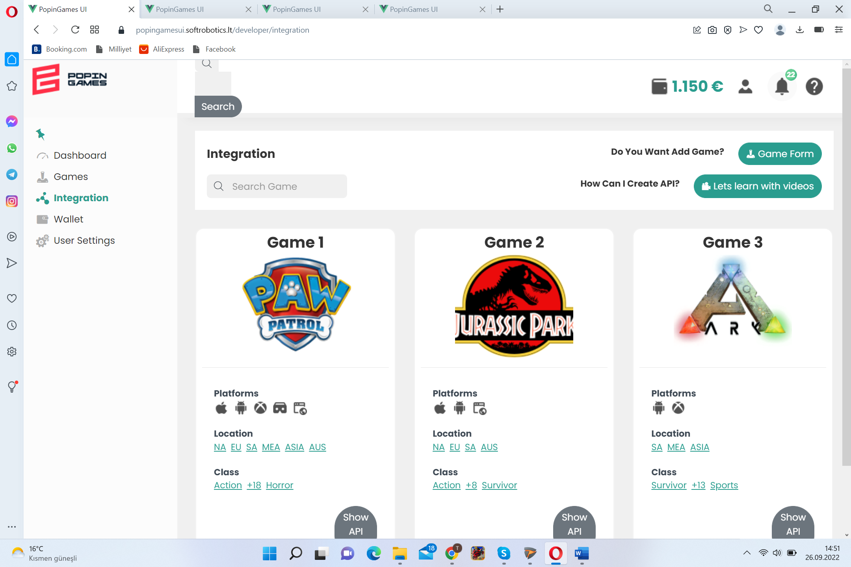 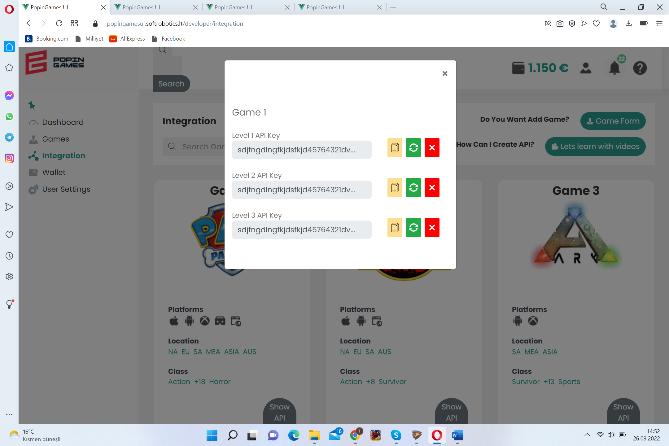

<https://popingamesui.softrobotics.lt/developer/wallet>

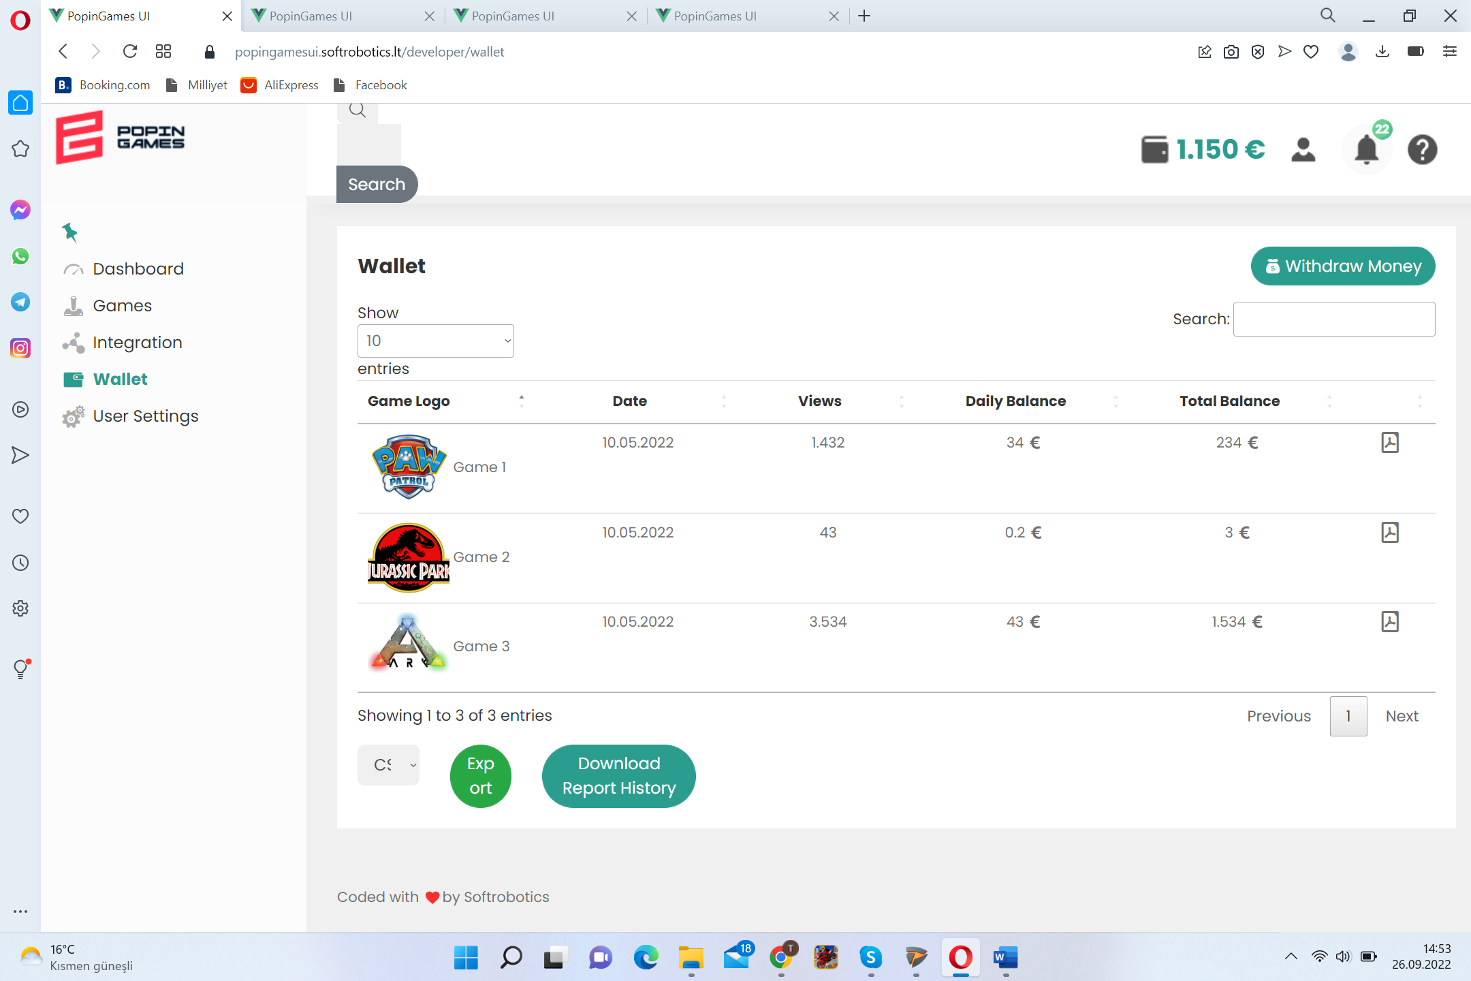 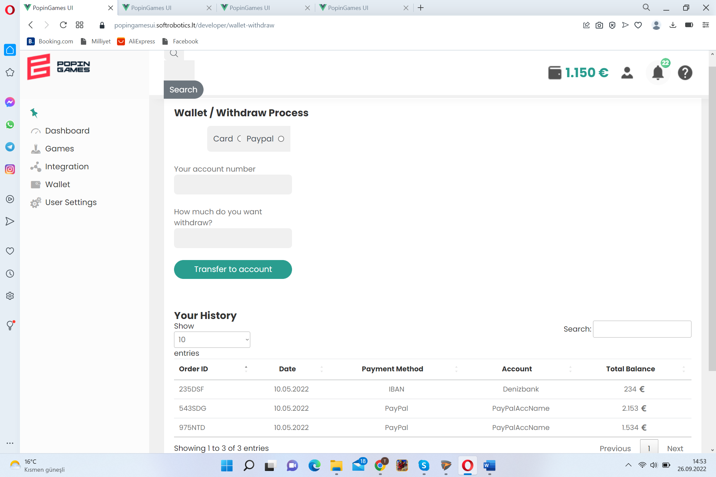

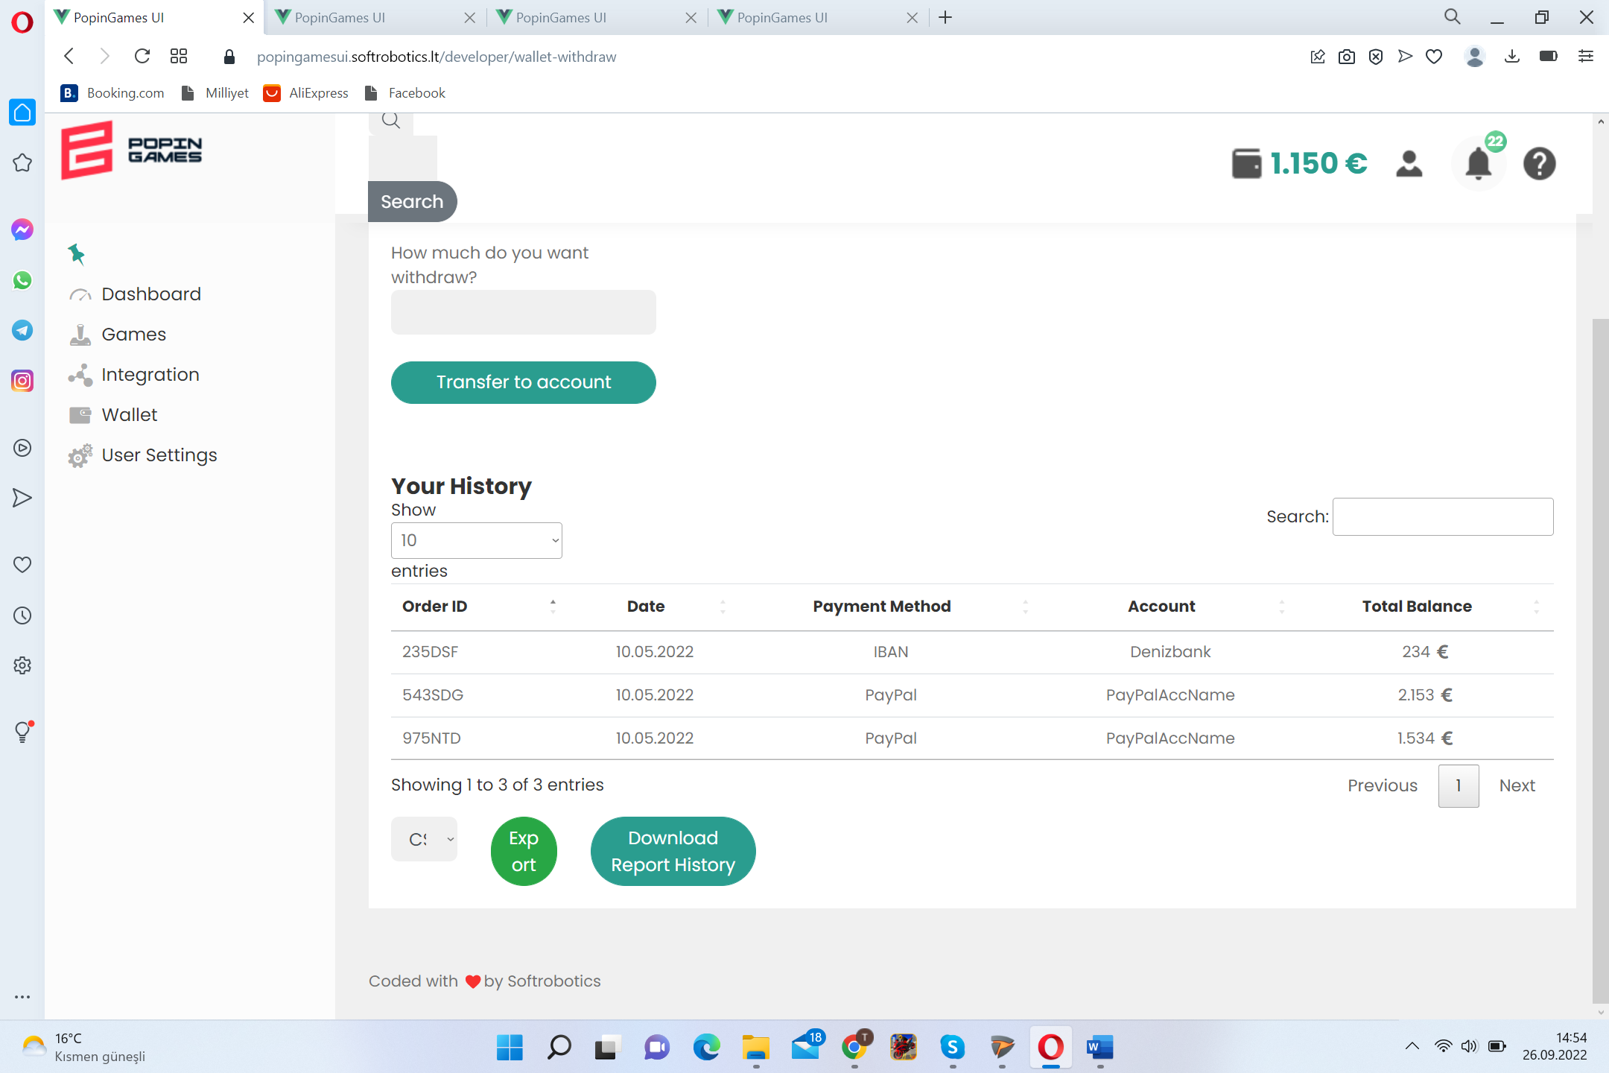

<https://popingamesui.softrobotics.lt/developer/user-settings>

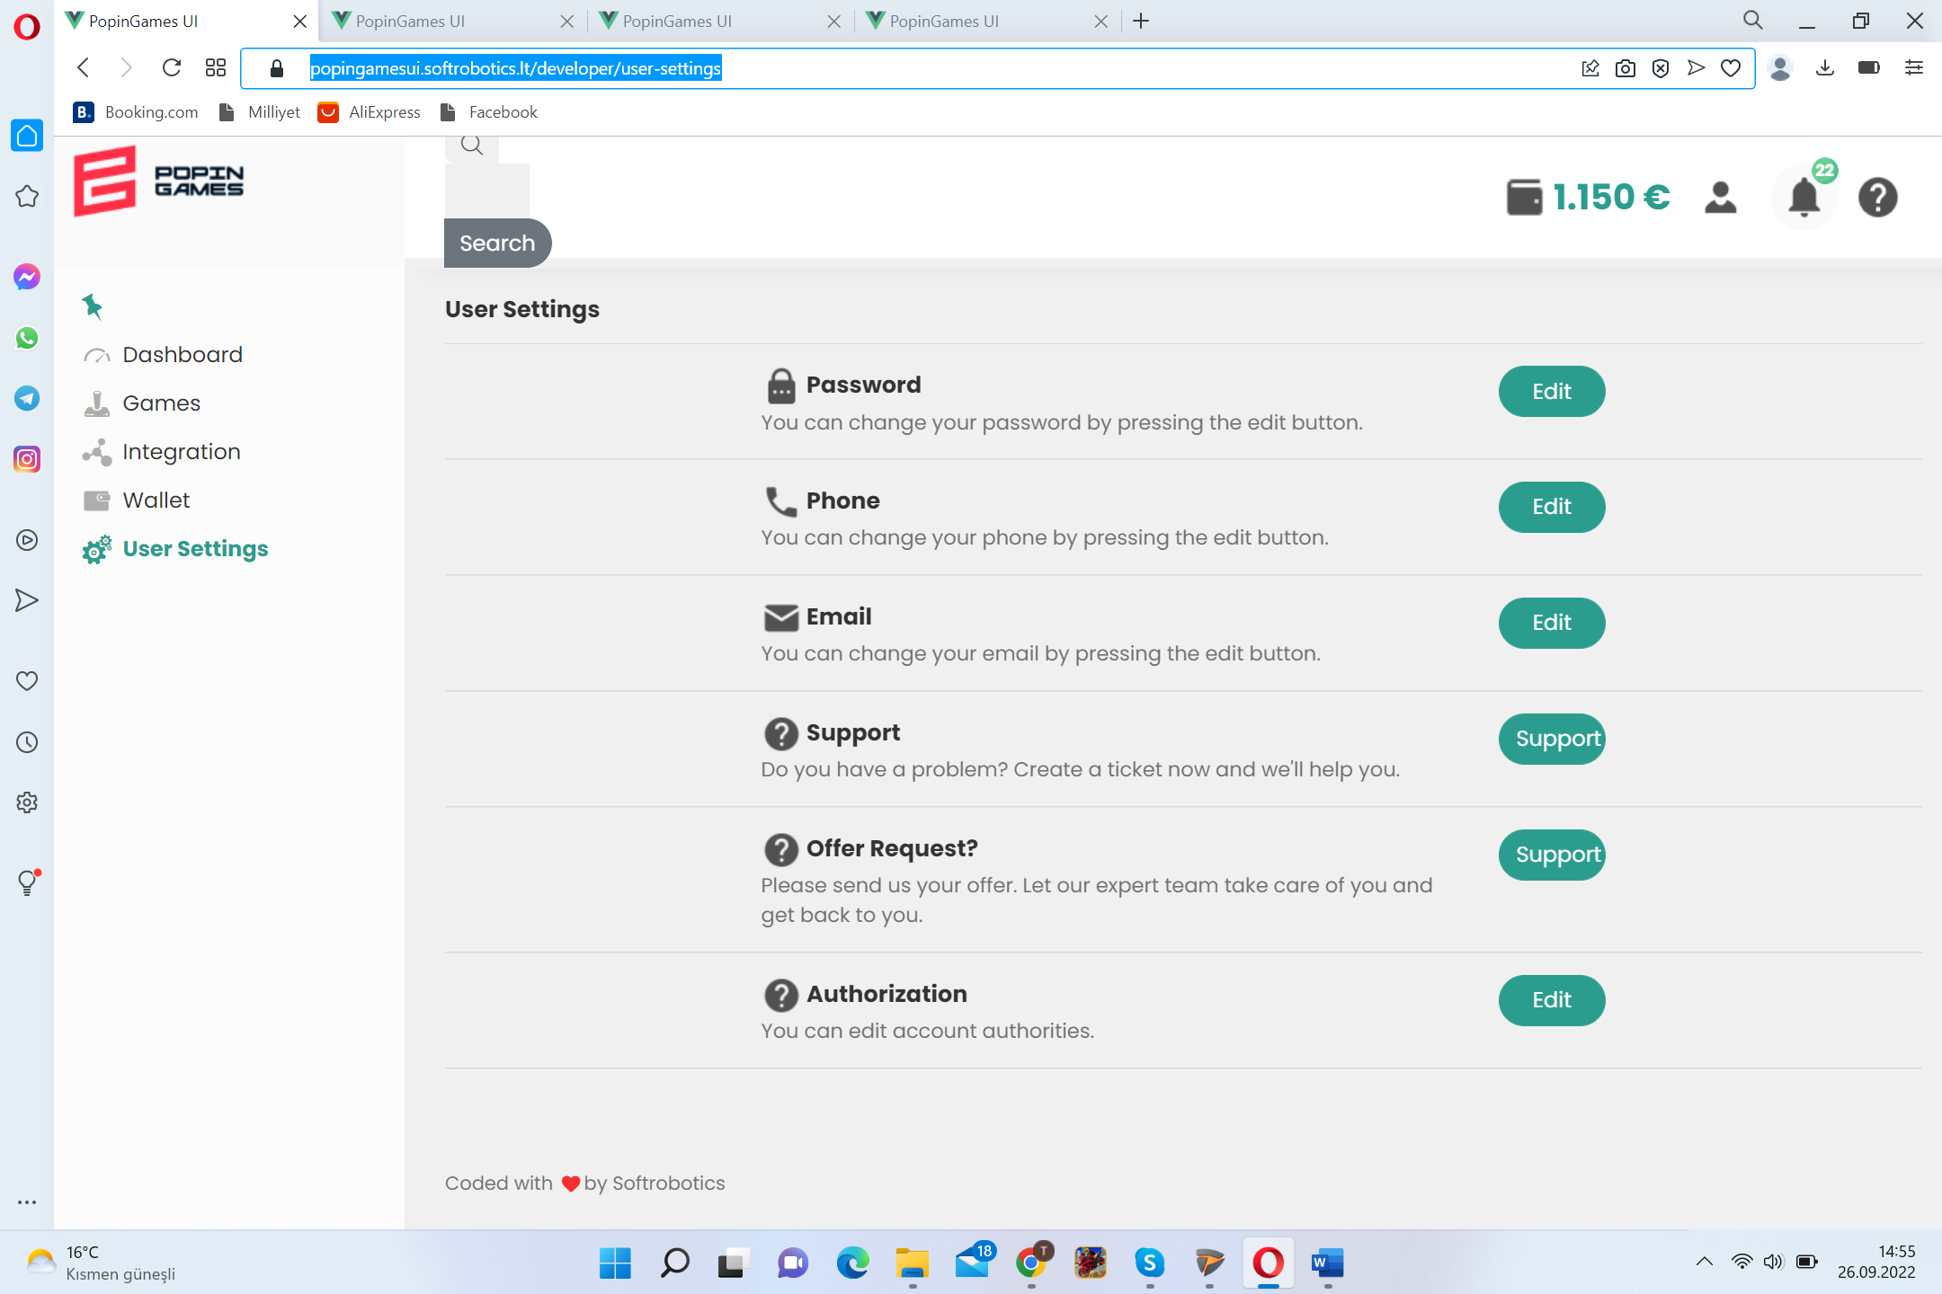 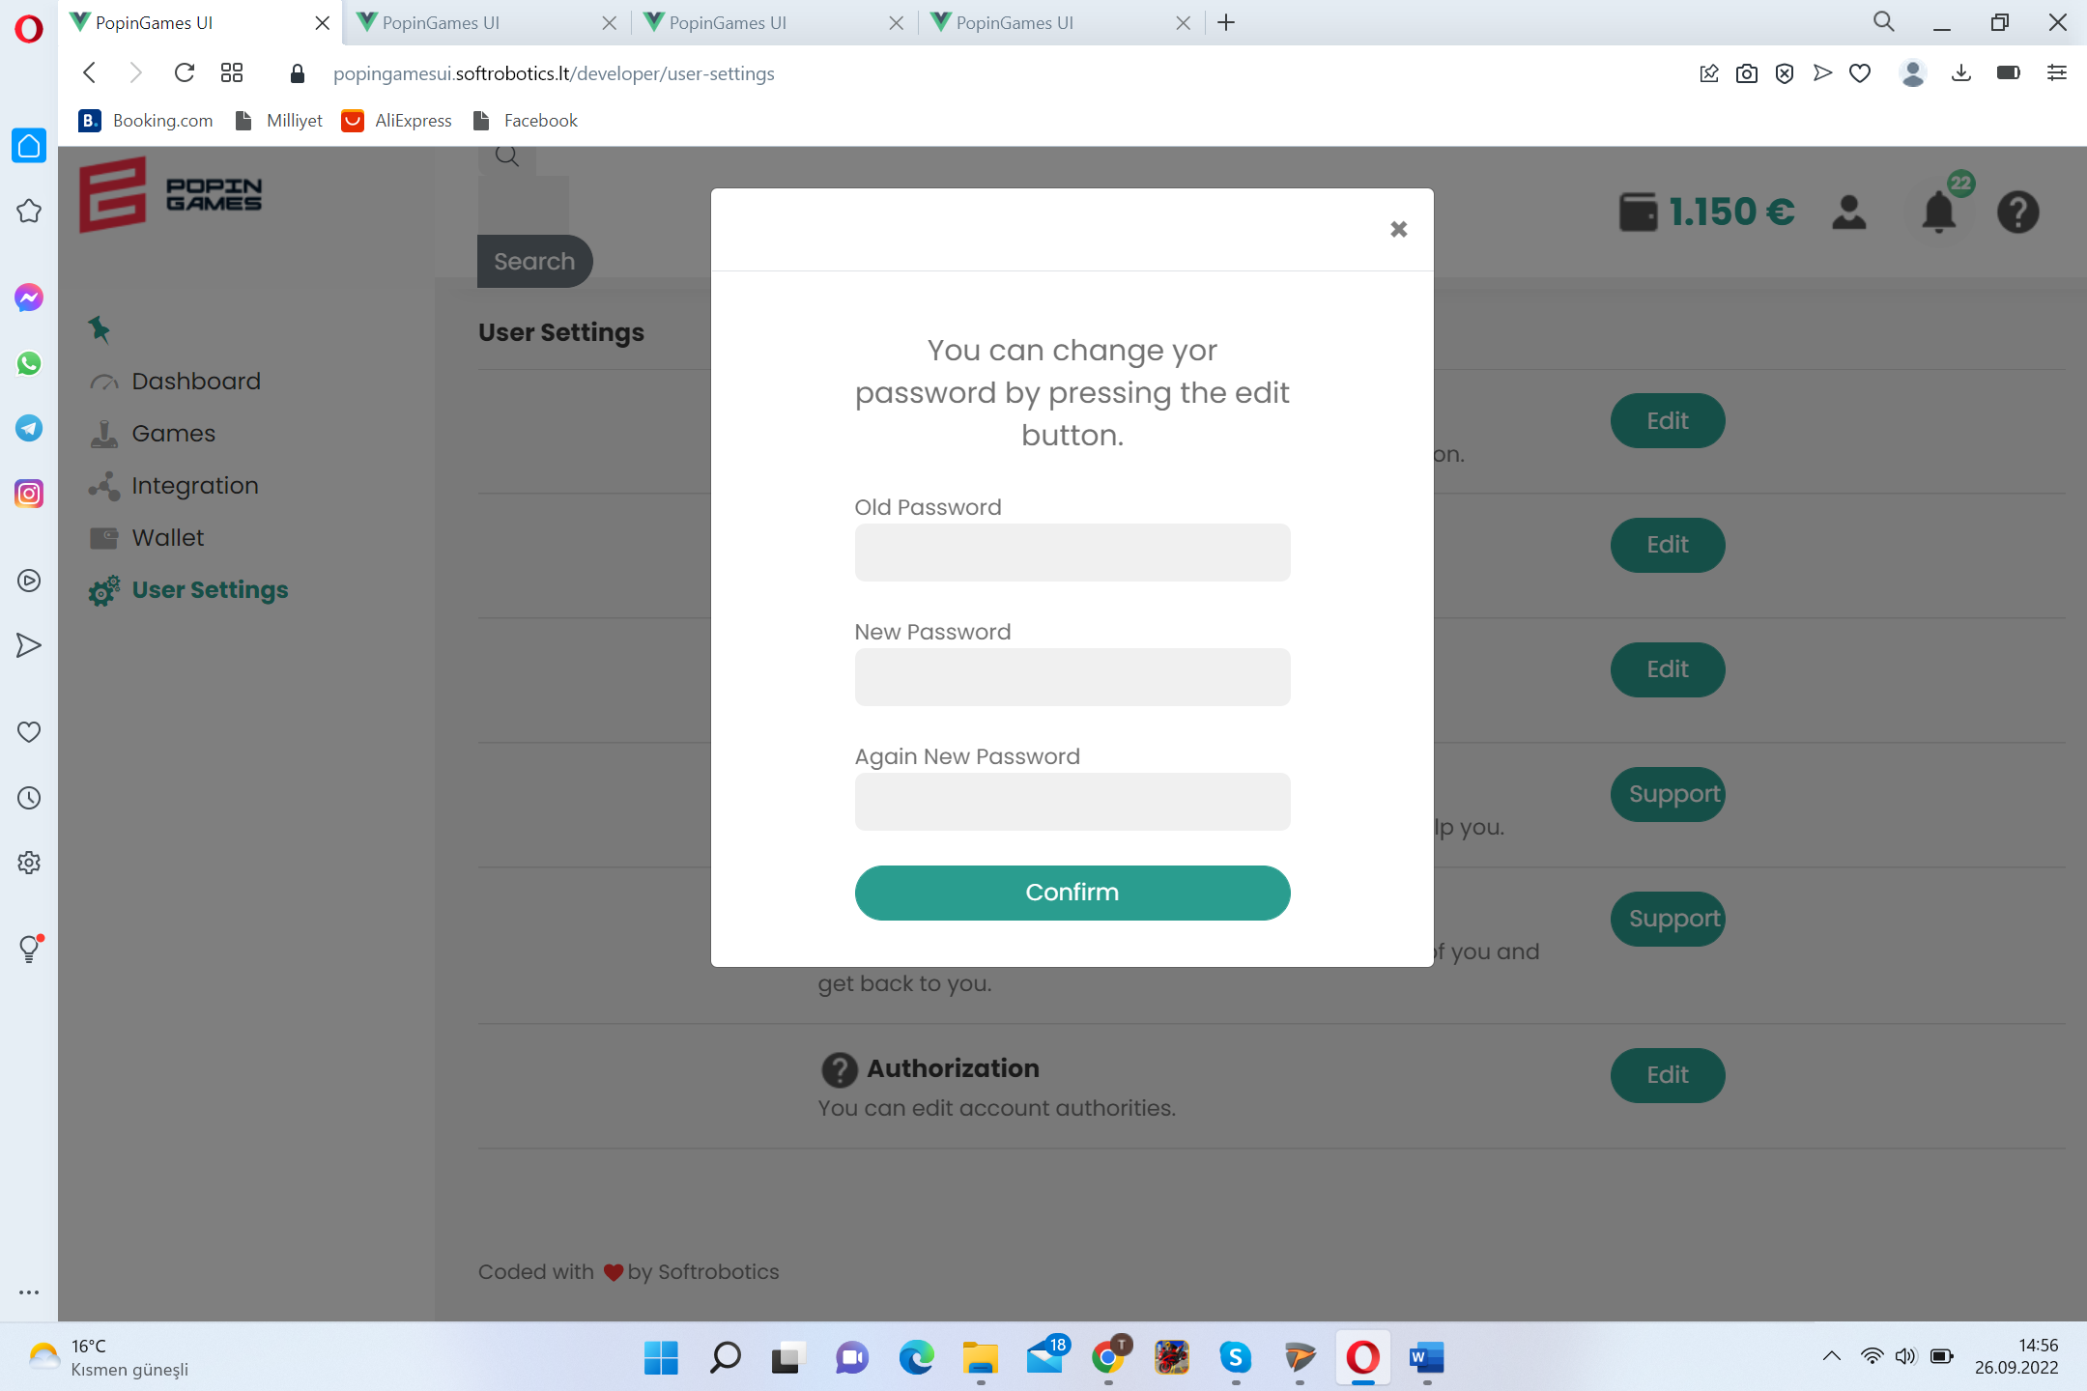

ADVERTISERS

Select region, select genre , select game, select target group, select specific ad spot, upload content for specific spots, request visual to be uploaded with additional cost from PopinGames, name campaign, add & hold & cancel campaign, copy previous campaign, add & withdraw credit to&from wallet, follow reports on campaign ( budget&credit letf,duration, number of games and ad spots involved, top (1-10) games attracted by viewers, #of clicks, #of views, most seen ad spot), # of campaigns.

<https://popingamesui.softrobotics.lt/advertiser/dashboard>

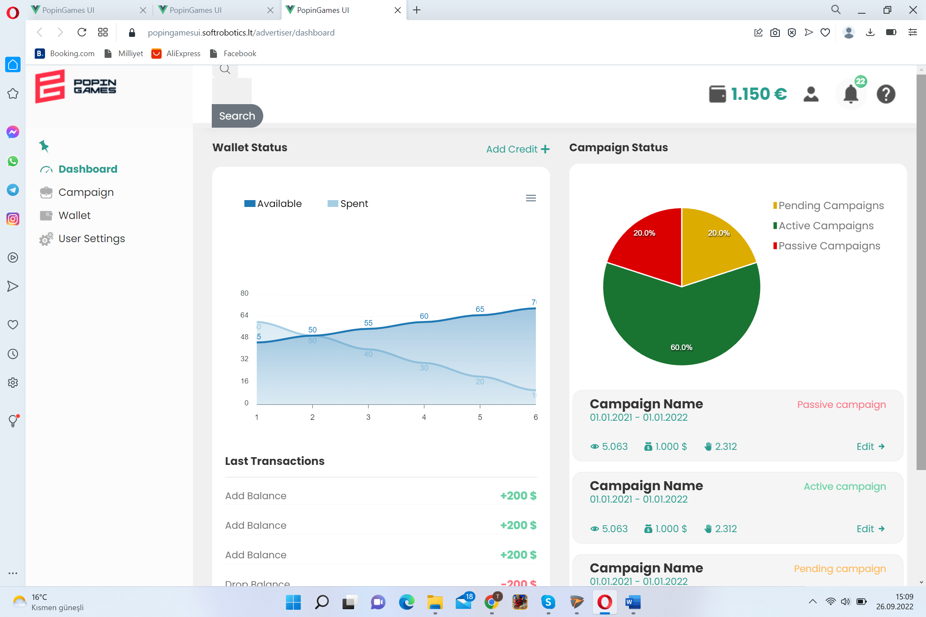 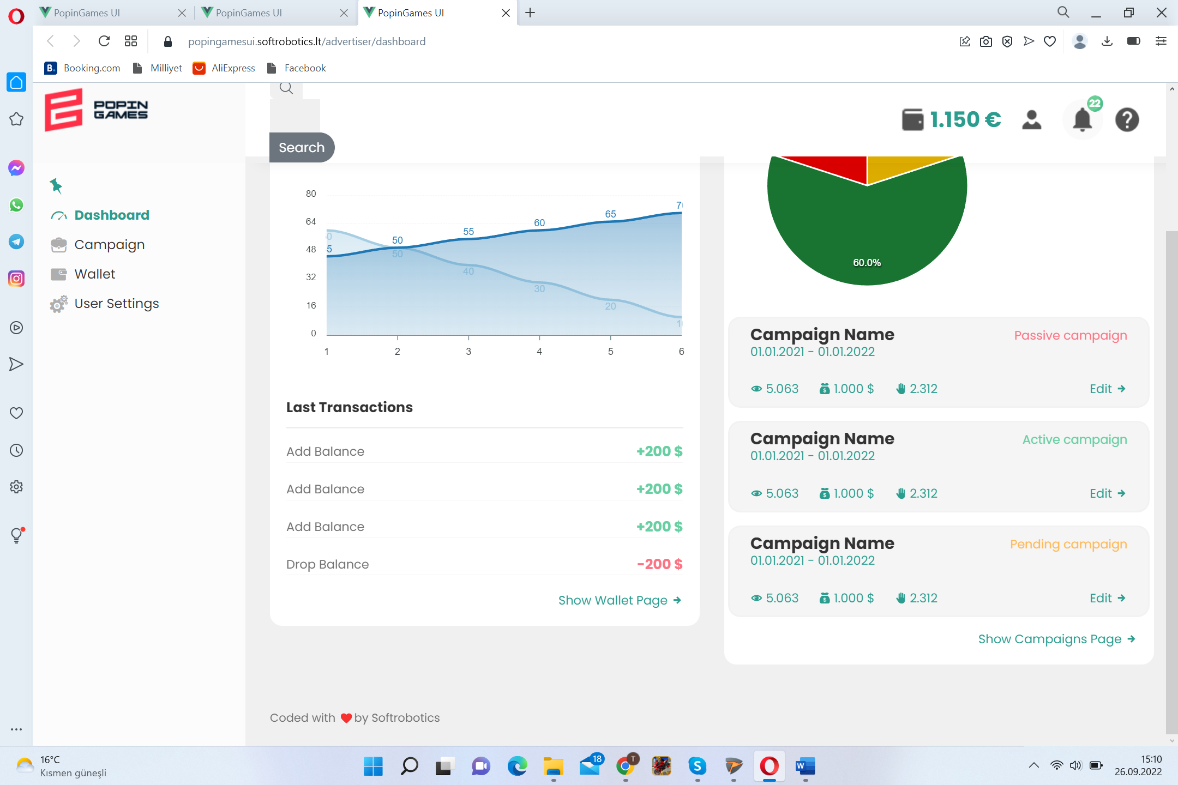

<https://popingamesui.softrobotics.lt/advertiser/campaign>

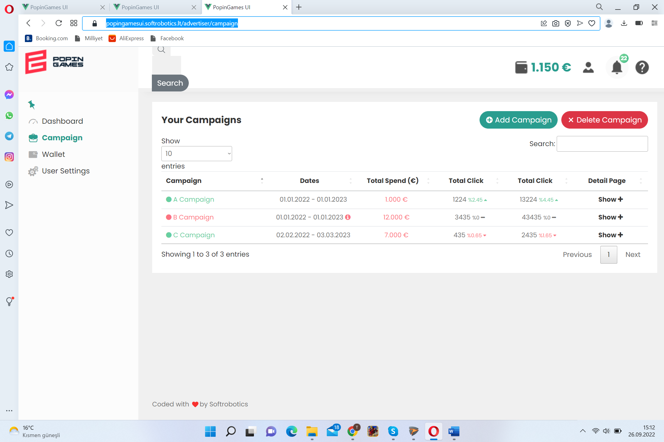 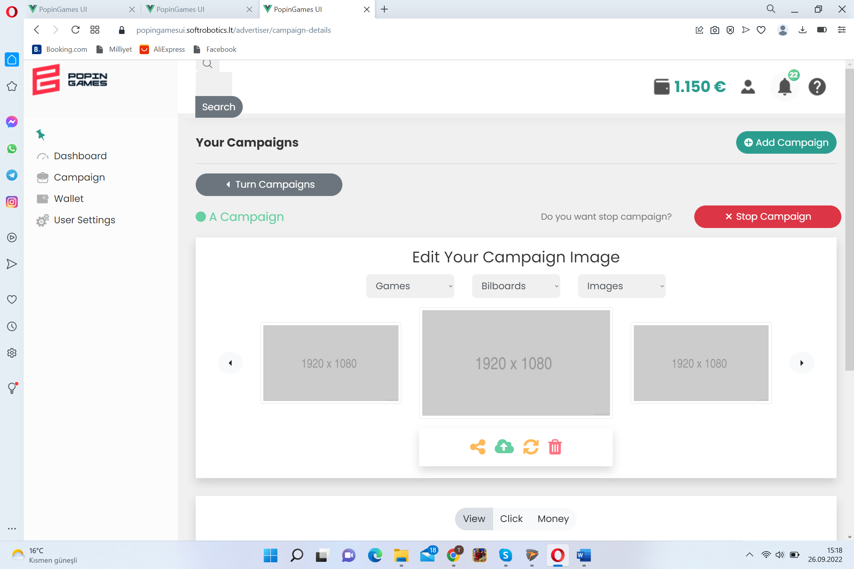

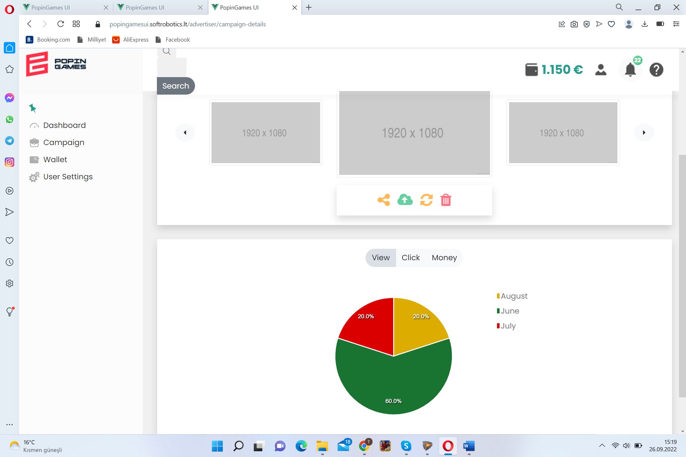

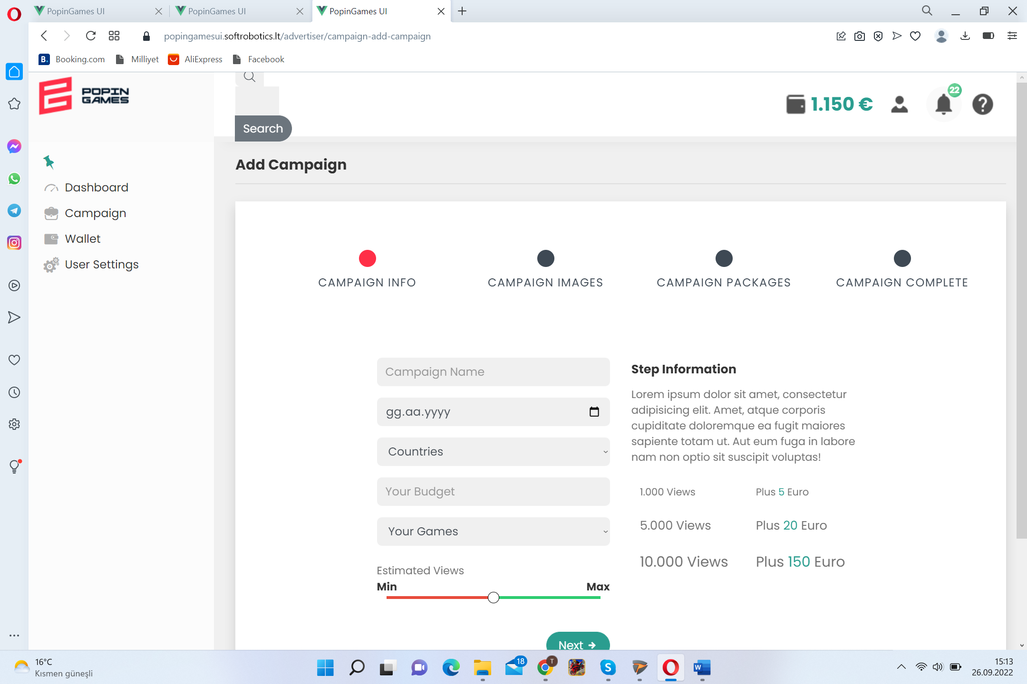 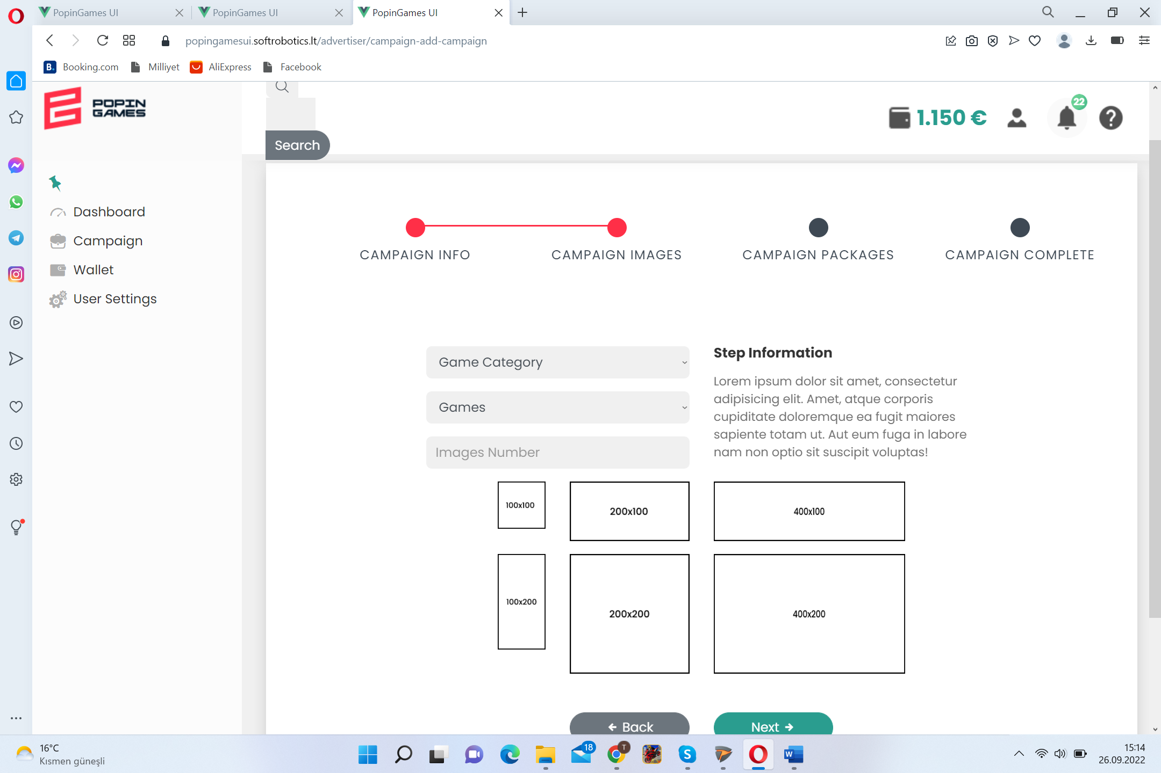

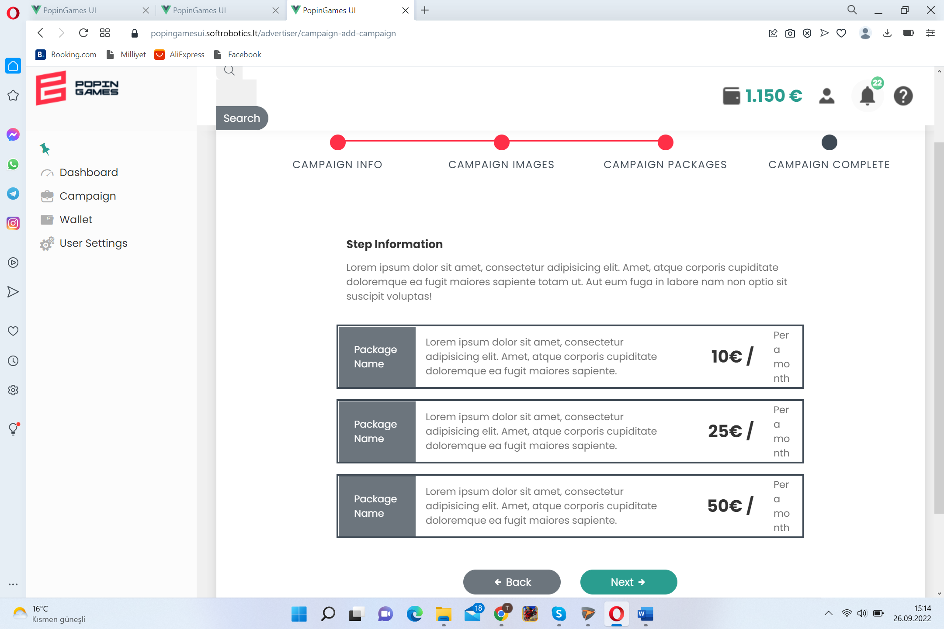 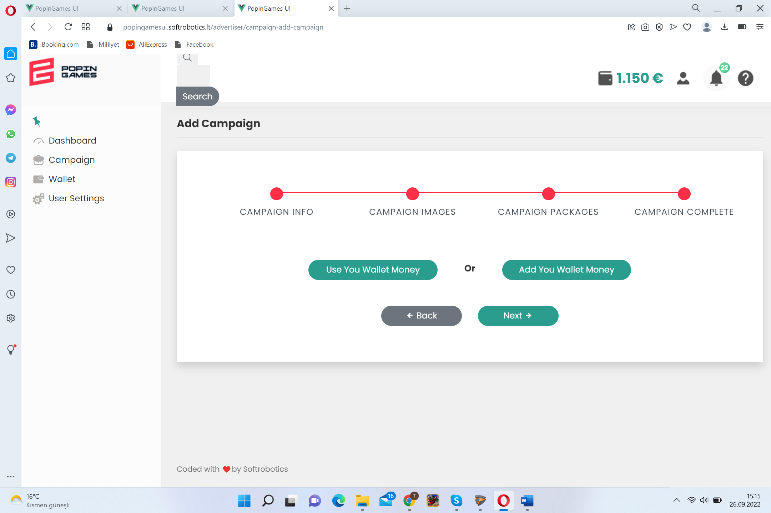

<https://popingamesui.softrobotics.lt/advertiser/wallet>

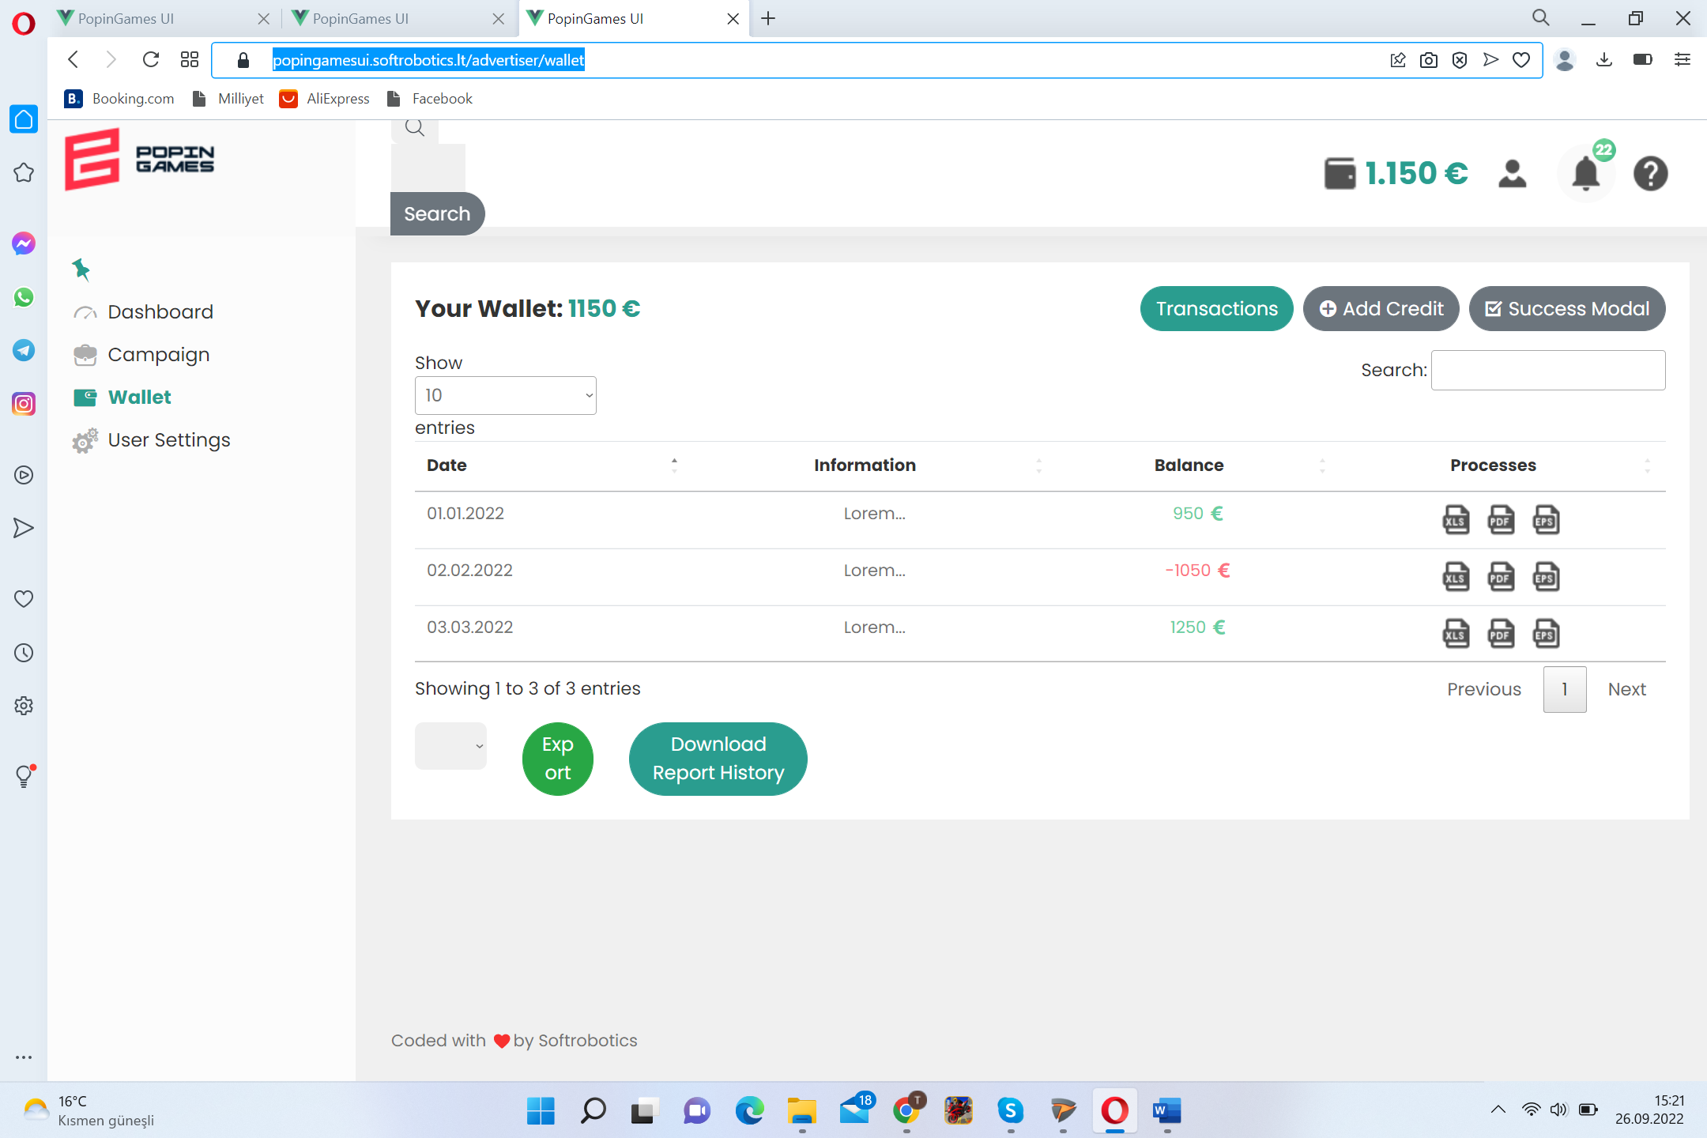 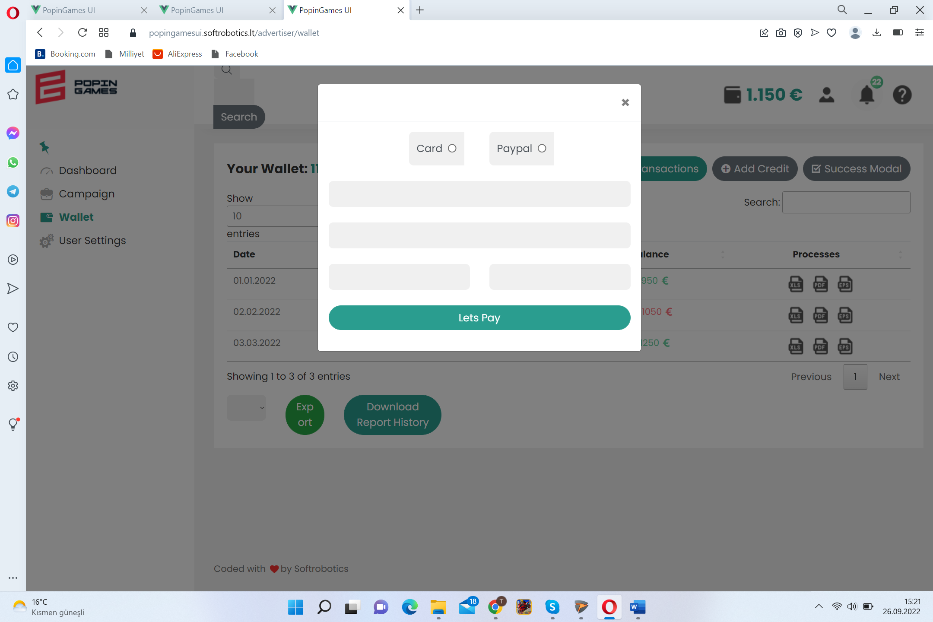

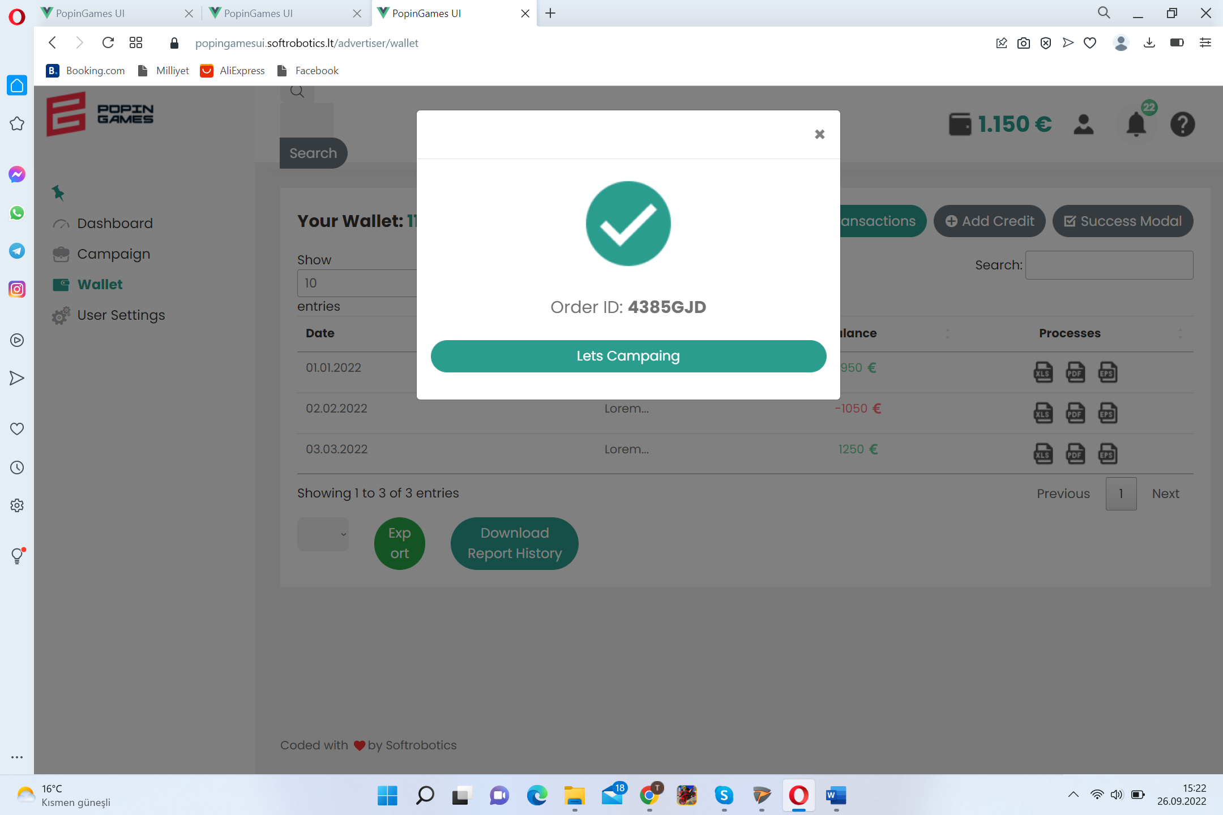

<https://popingamesui.softrobotics.lt/advertiser/user-settings>

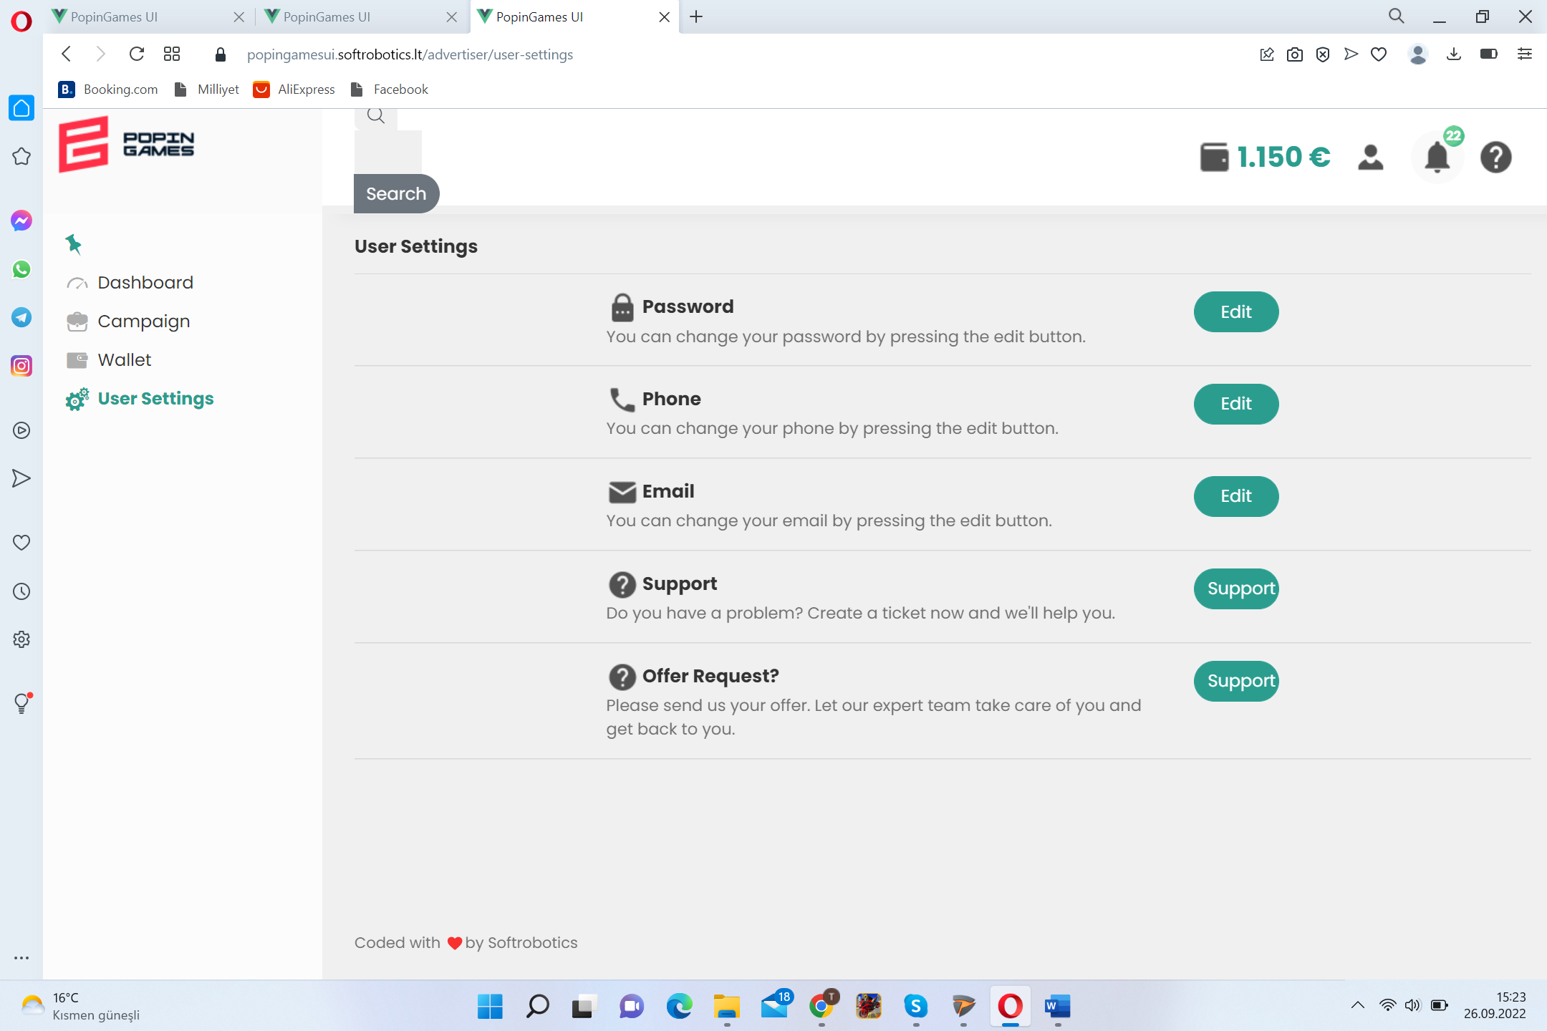 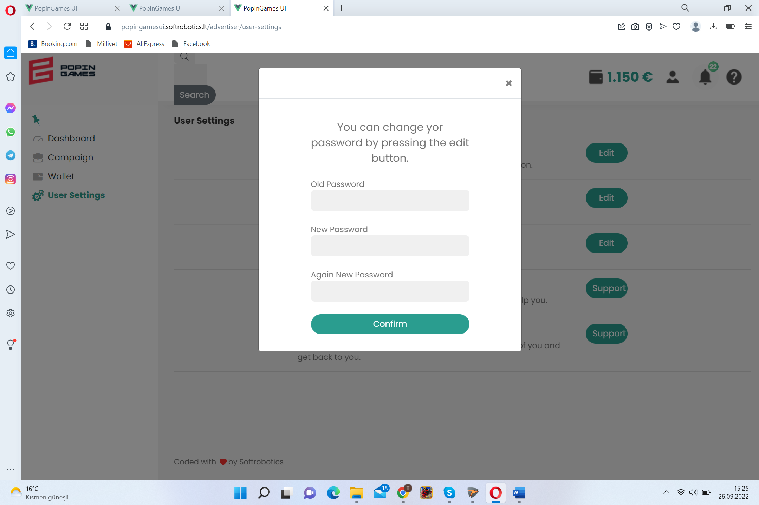

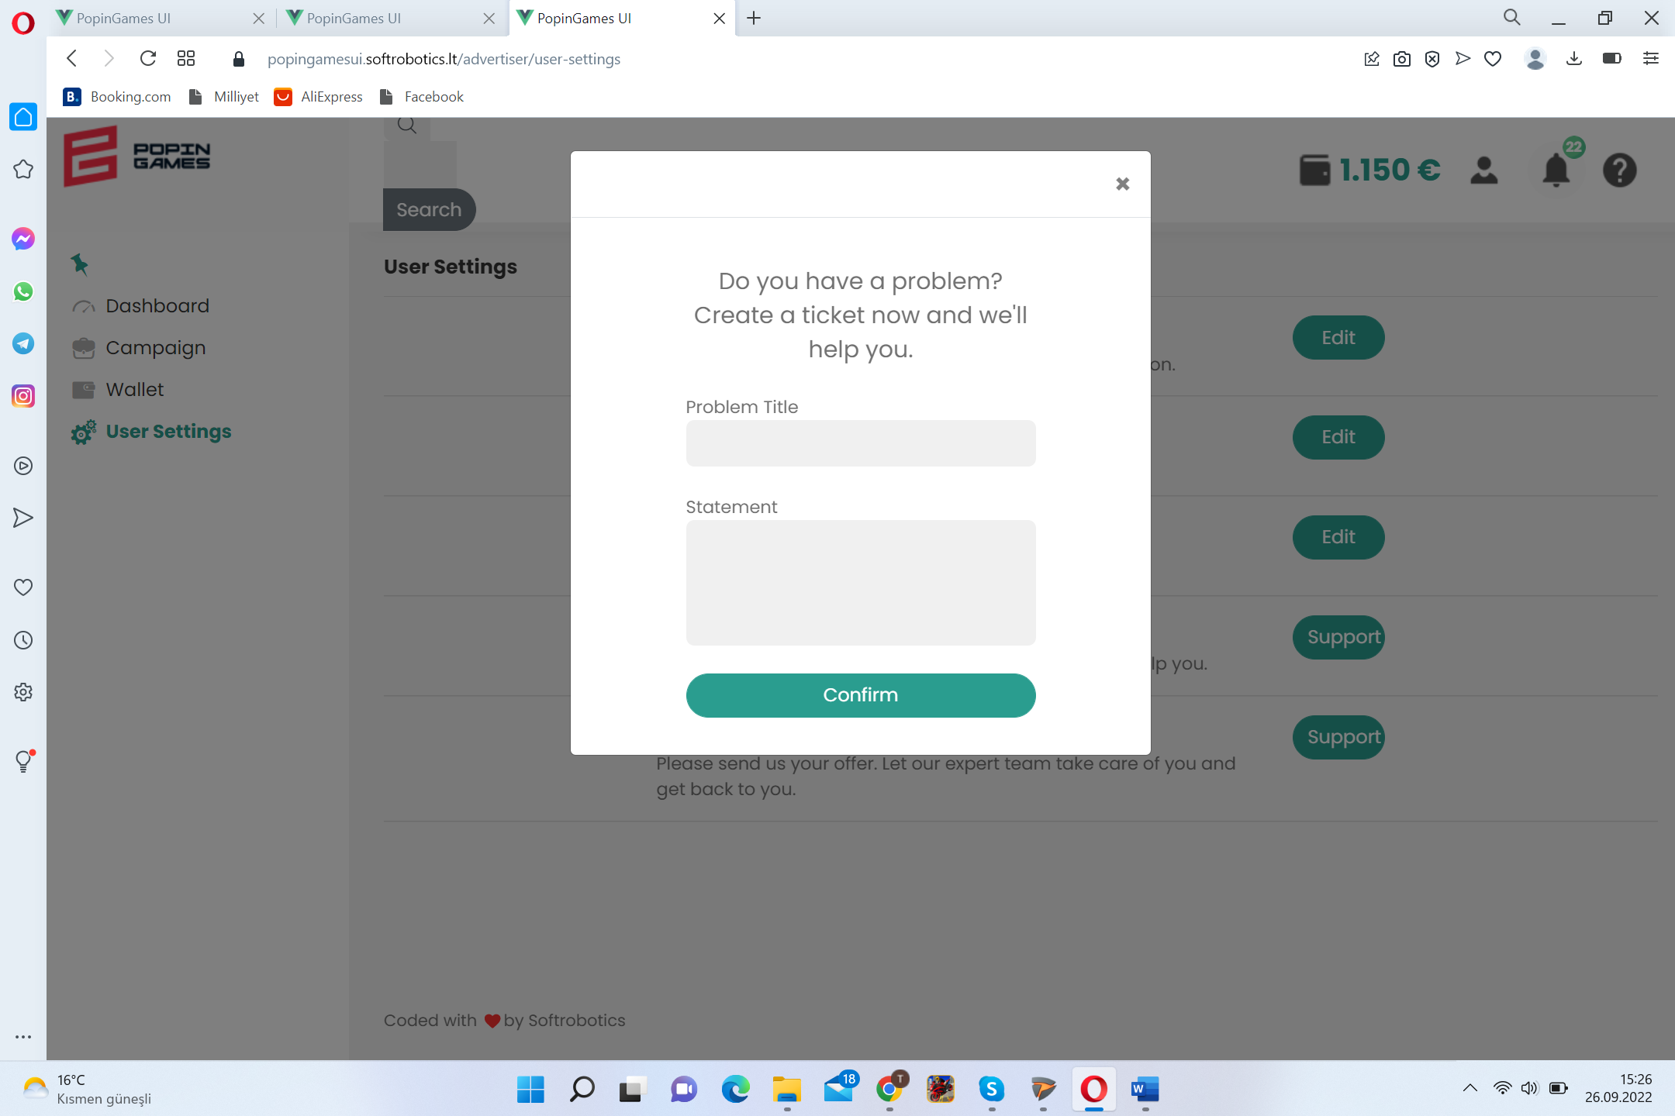

ADMIN

Able to see ( for selected time line-day-this week-7 days-month-this year-year): #of games, #of game studios, #of game developers, #of advertisers, #of brands, #of campaigns per advertiser&per brand&per game, #of ad spots, top 10 most preferred game & ad spot, budget & spending&balance per campaign, total cash, total withdrawn cash by developers&publishers, average budget & view &clicks per campaign, earnings per game &per developer &per game studio, top 3 genres in terms of; budget spent & views

#of games by region, number of advertisers & brands by region

# of Open & resolved tickets, ticket resolution length, top 5 ticket causes, admin operators by resolution; number, speed, type

#of blocked developers & advertisers & brands by period ( day – week-month-6 month-year)

Able to ; set custom campaign, hold & stop campaign, upload content on behalf of Advertiser ( with charge), black list advertiser &brand & game studio&game developer&Publisher. Check content of each campaign and approve to gol ive

Authority Levels of Admin: 1- general fully authorized, 2- business &finance issues, 3- technical issues , 4-viewer only

<https://popingamesui.softrobotics.lt/admin/dashboard>

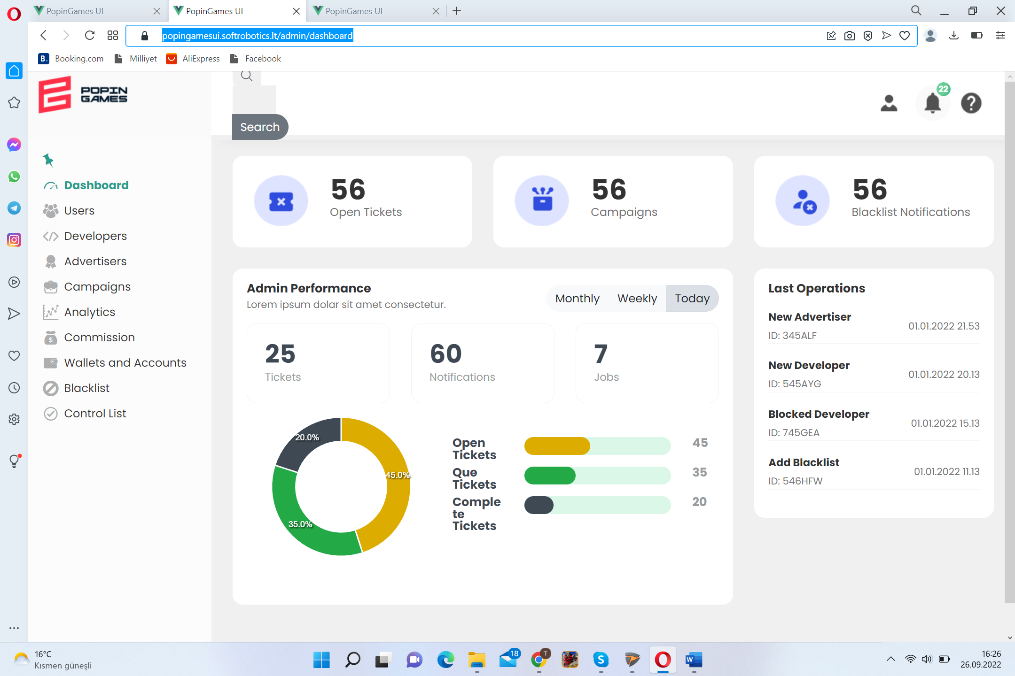

<https://popingamesui.softrobotics.lt/admin/users>

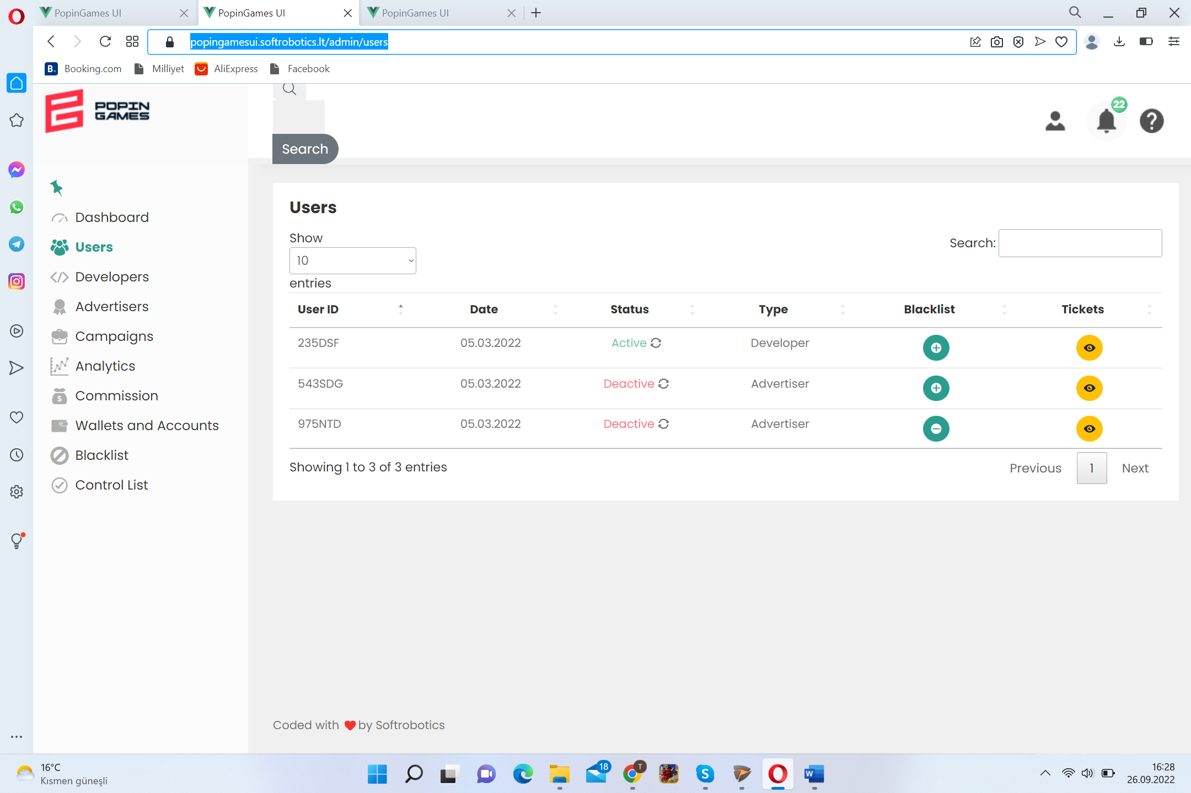 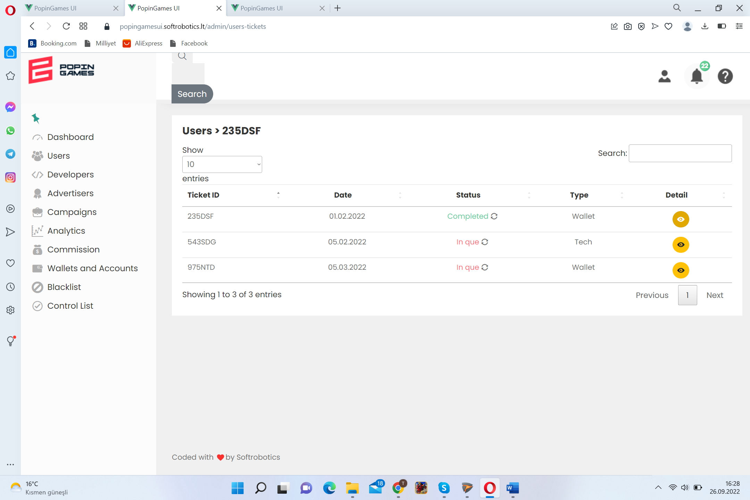

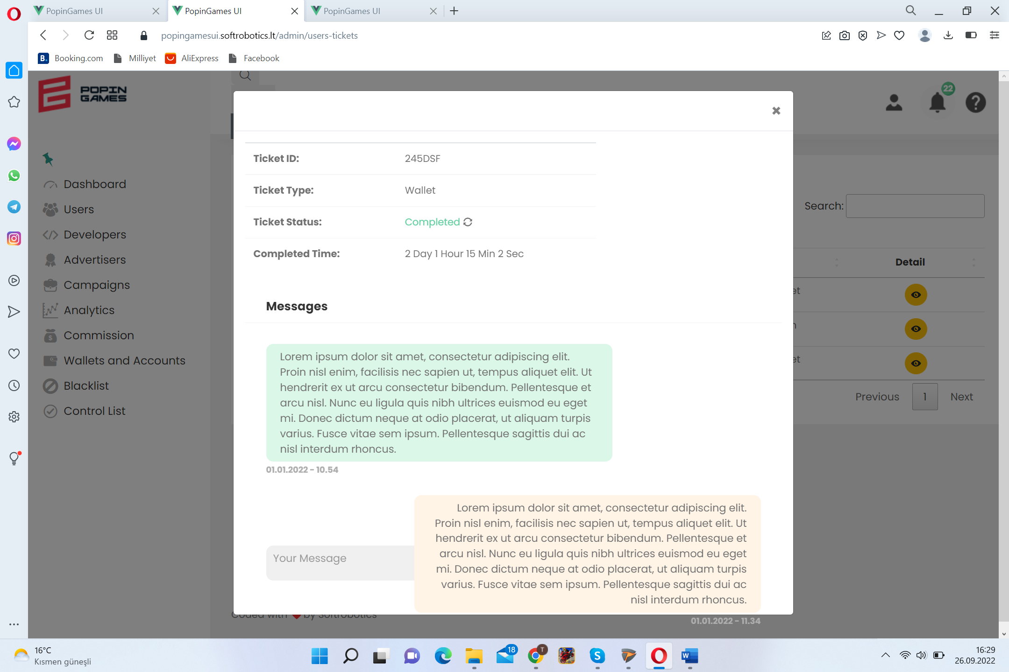

<https://popingamesui.softrobotics.lt/admin/developers>

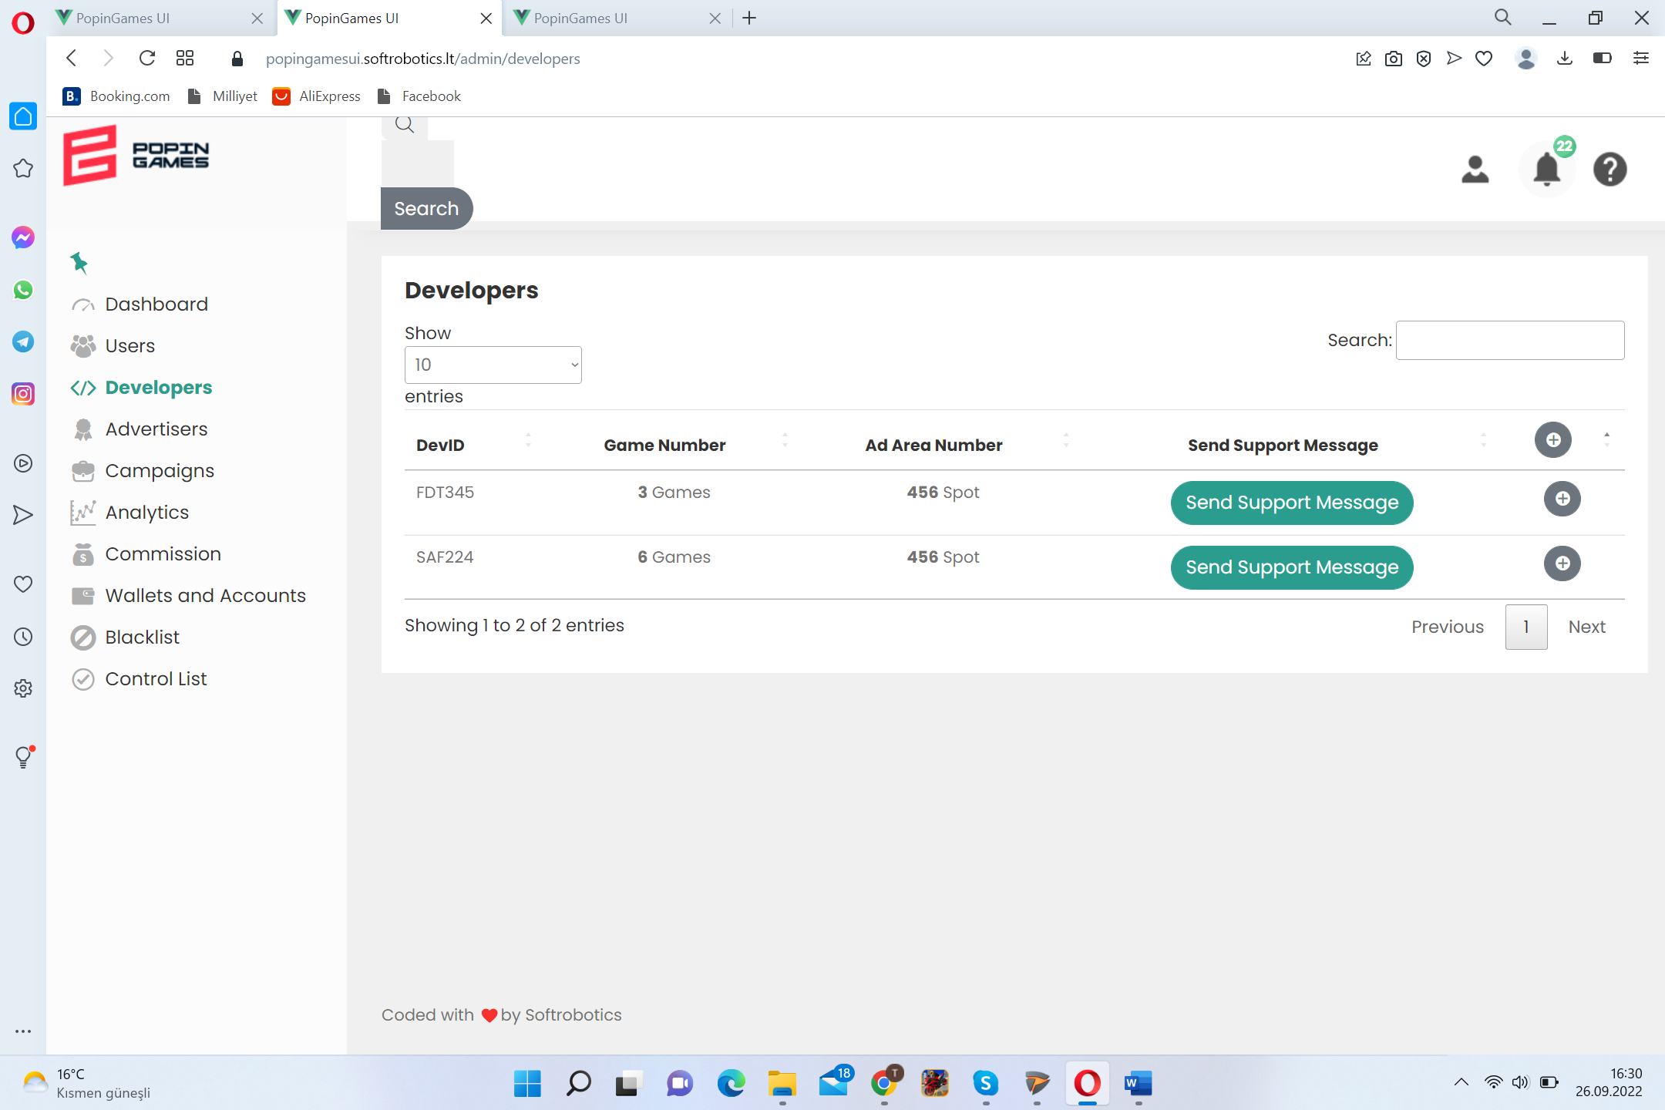

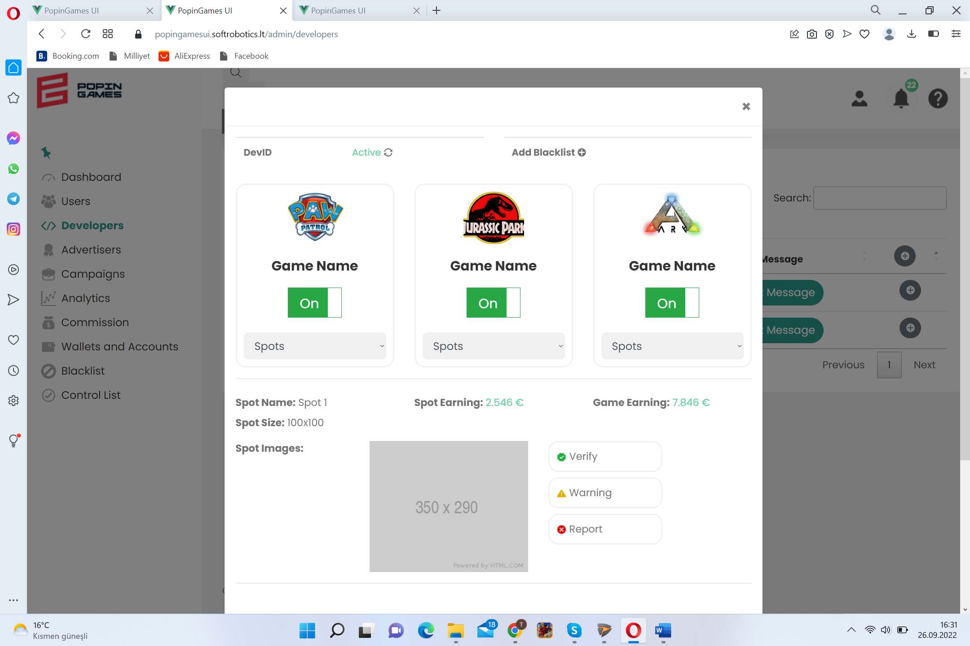 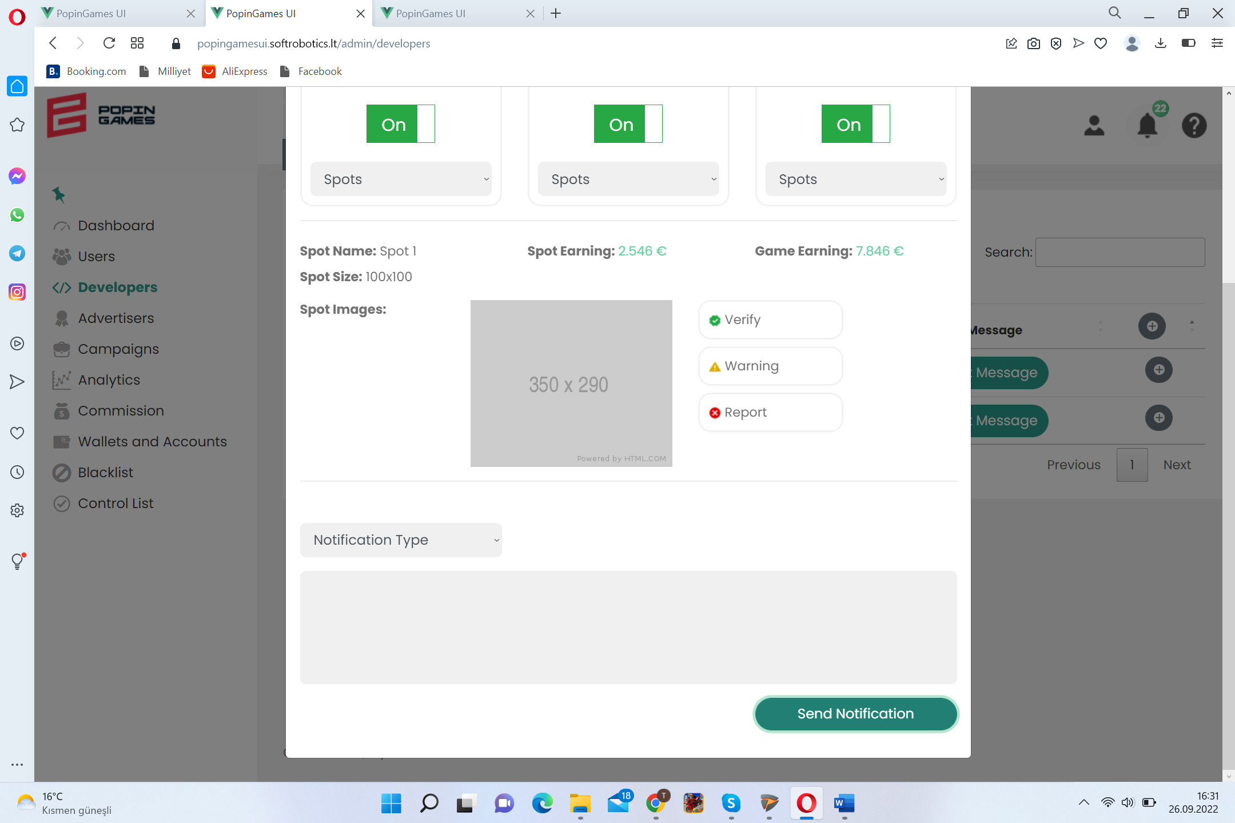

<https://popingamesui.softrobotics.lt/admin/advertisers>

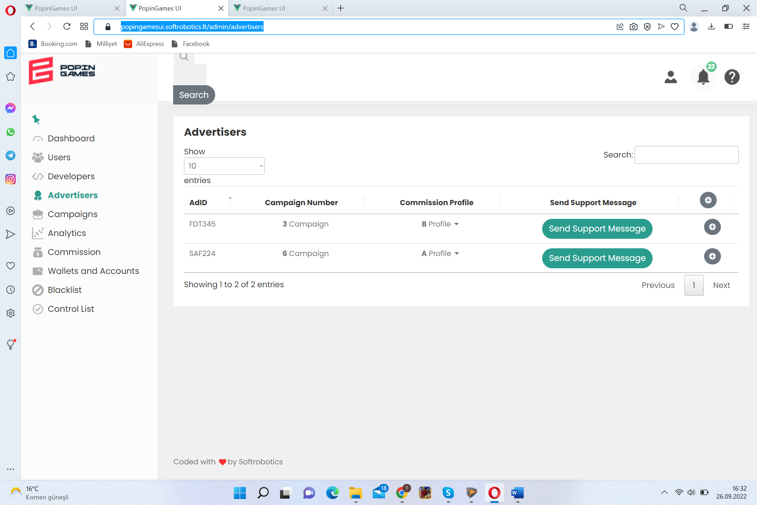 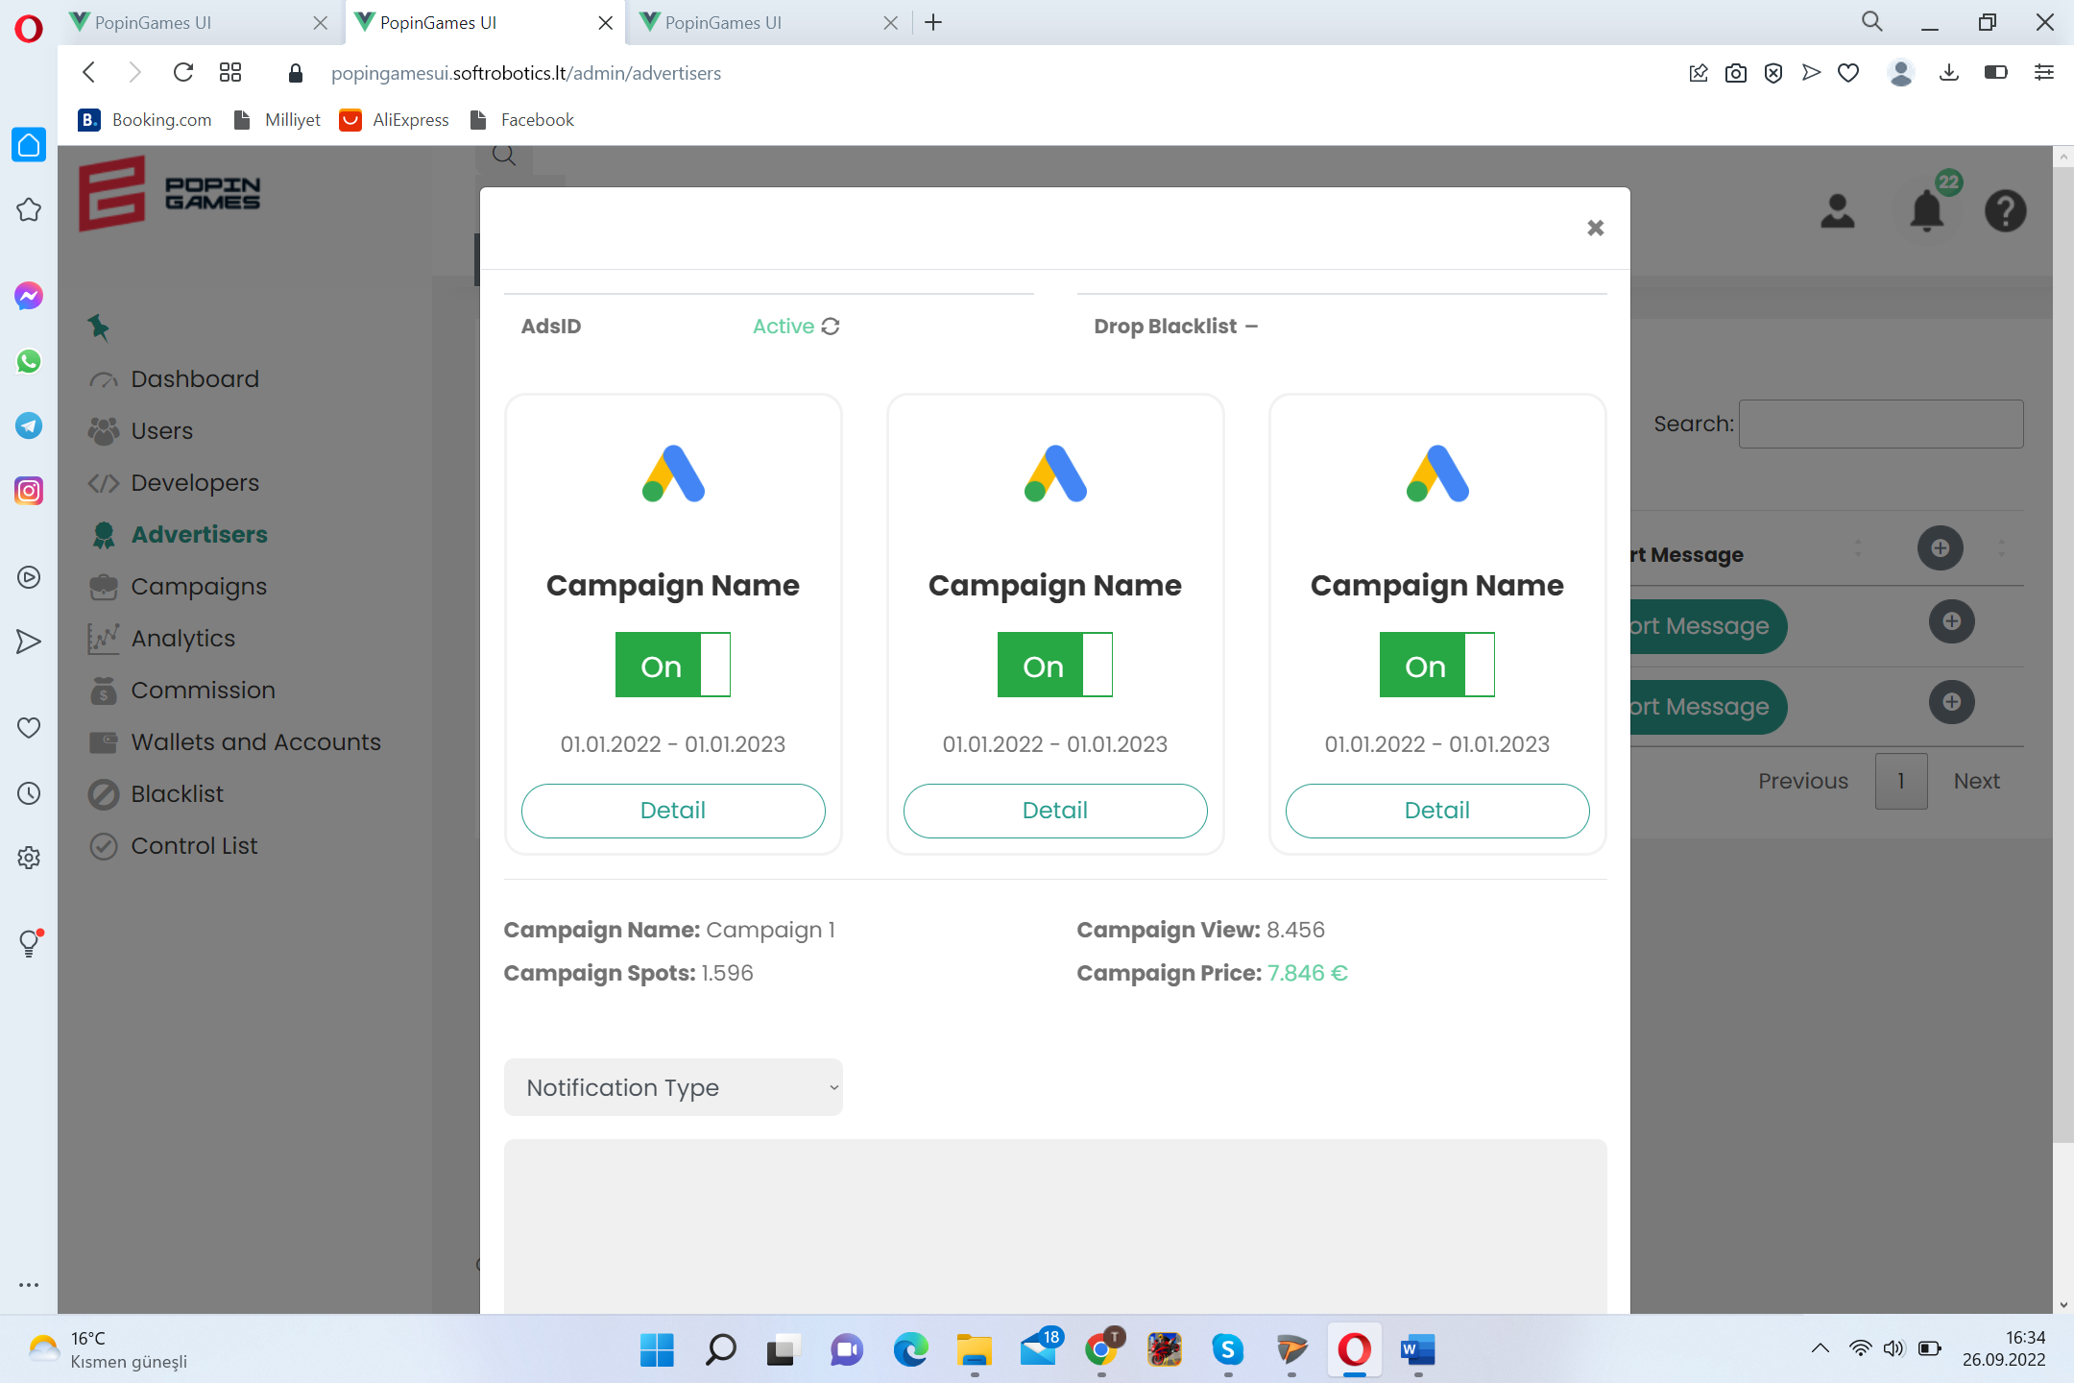

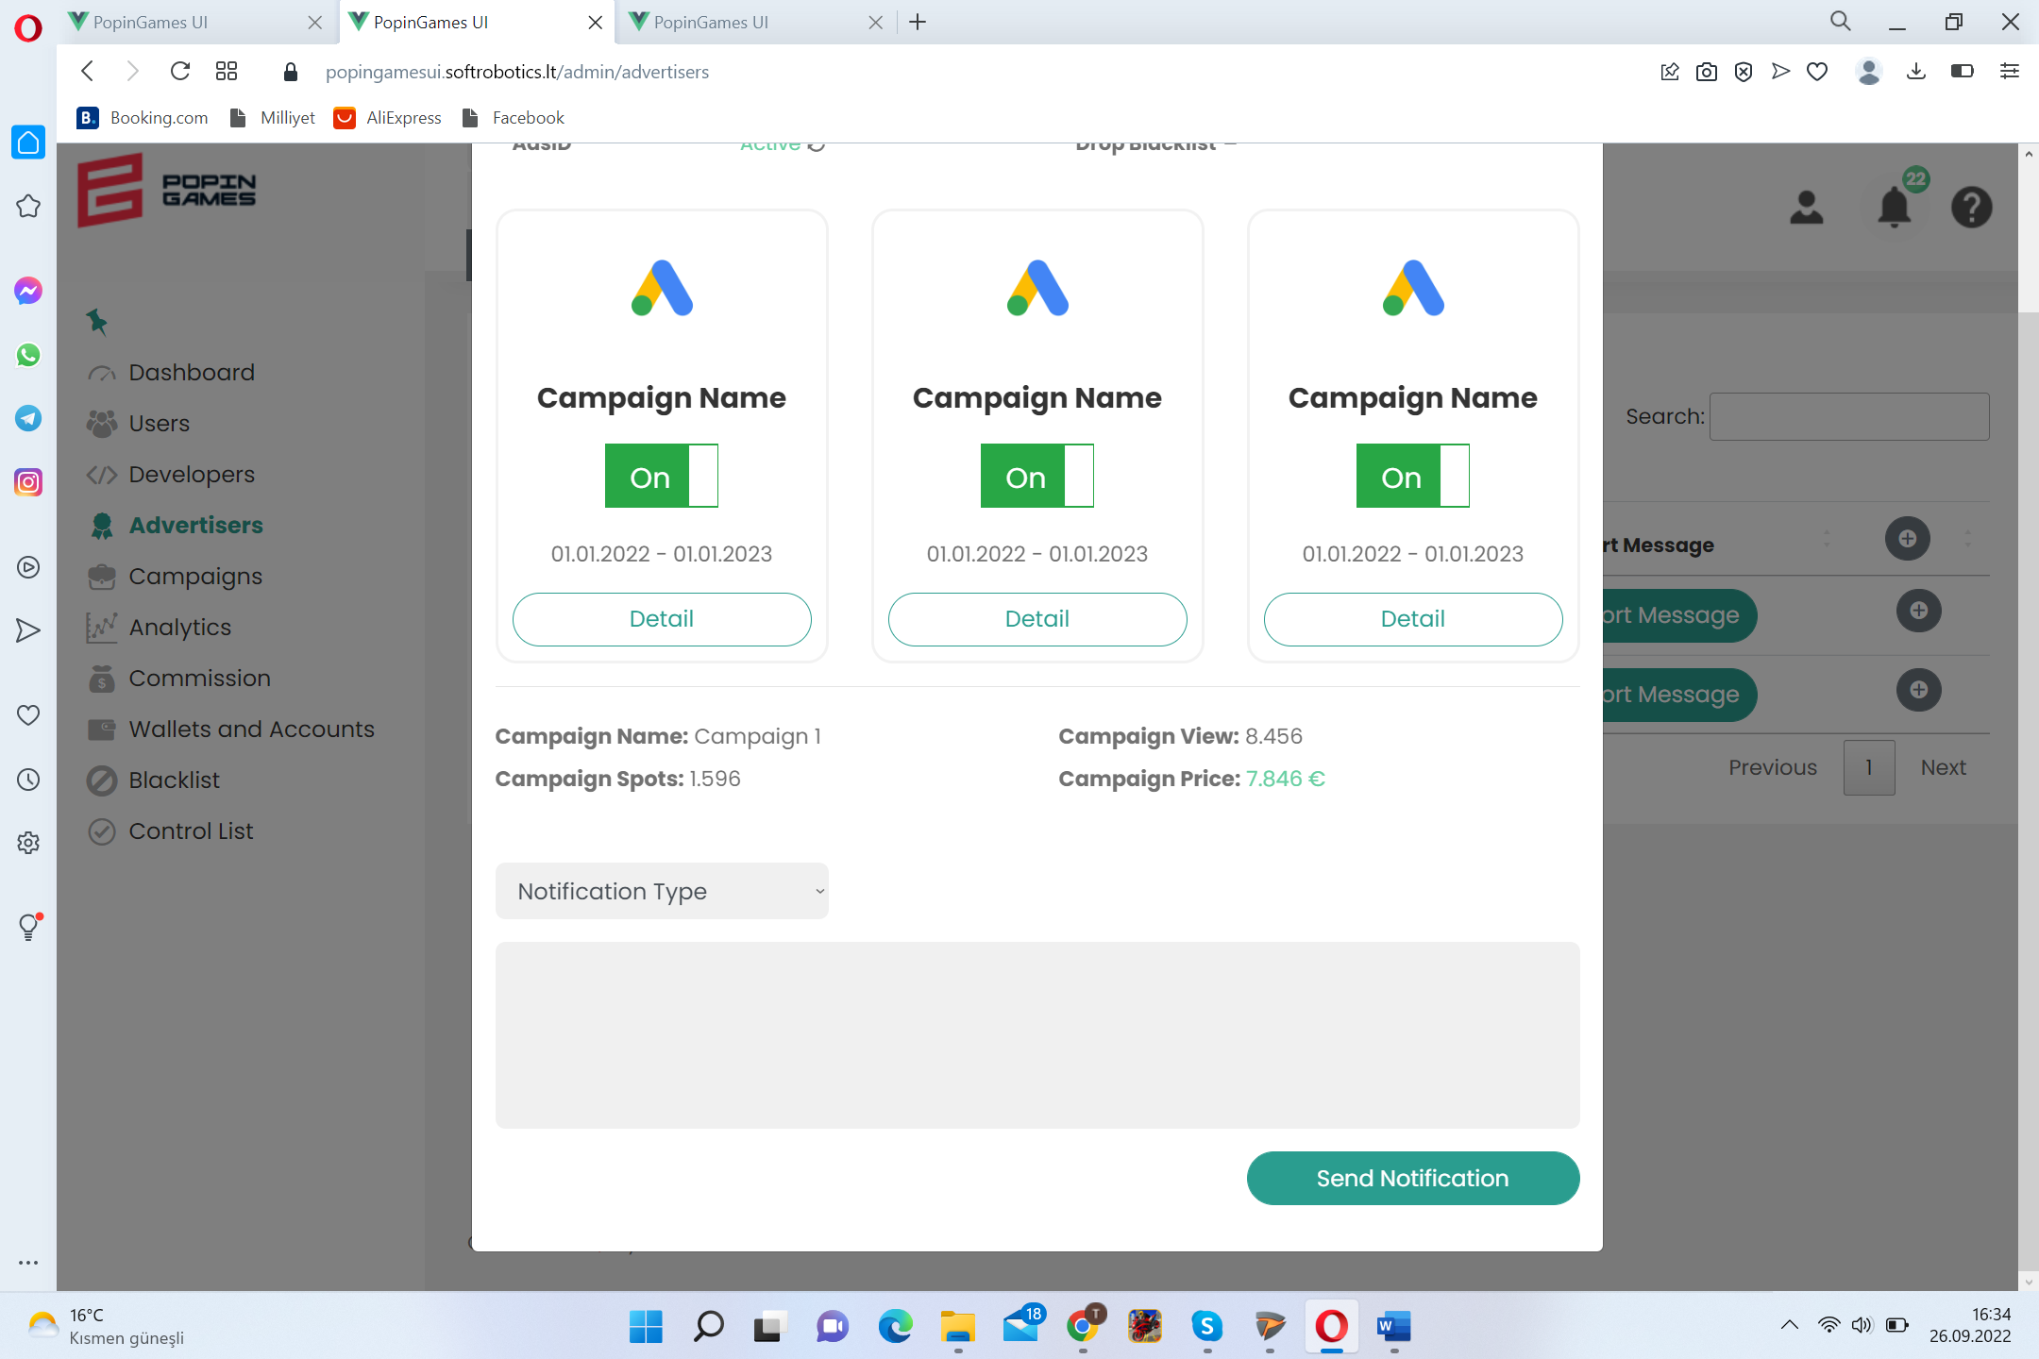

<https://popingamesui.softrobotics.lt/admin/campaigns>

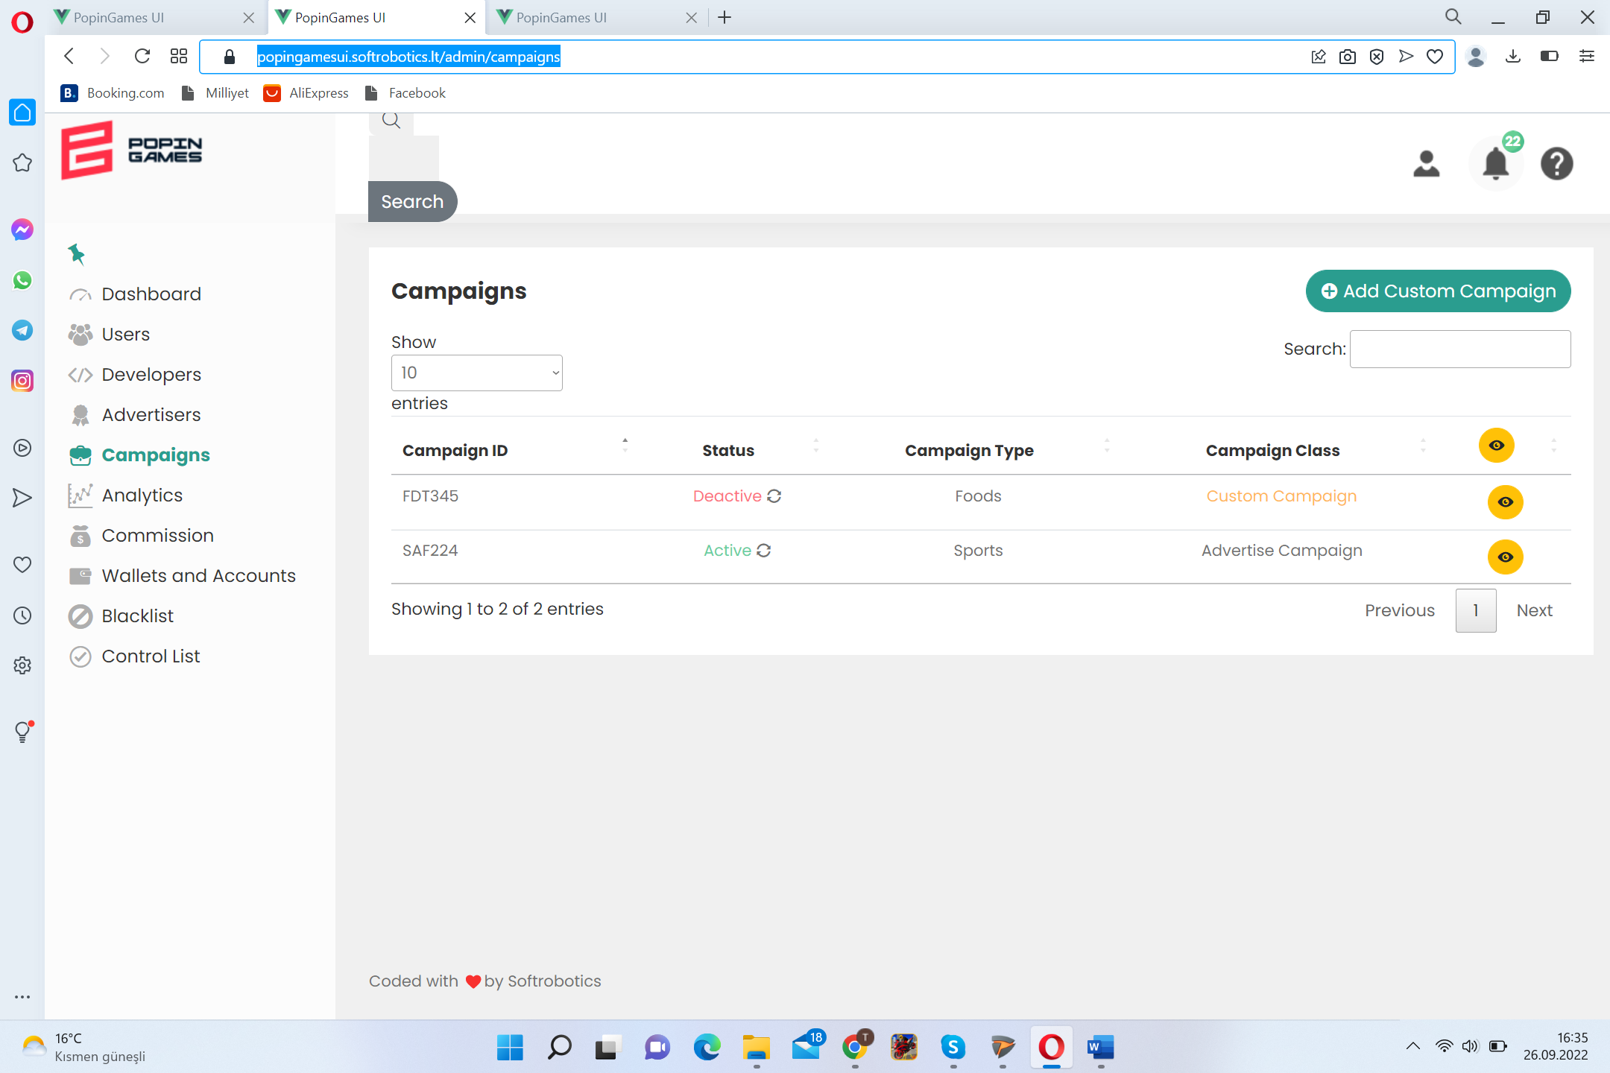 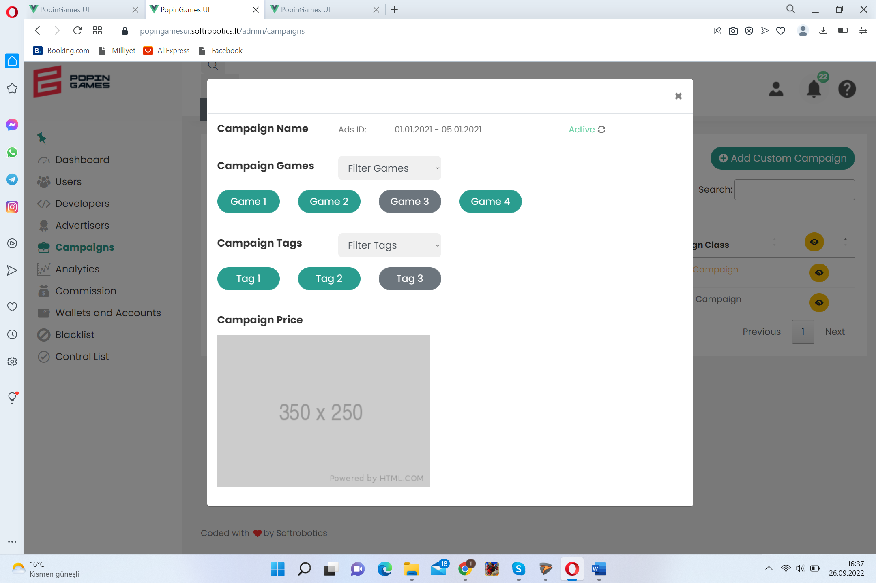 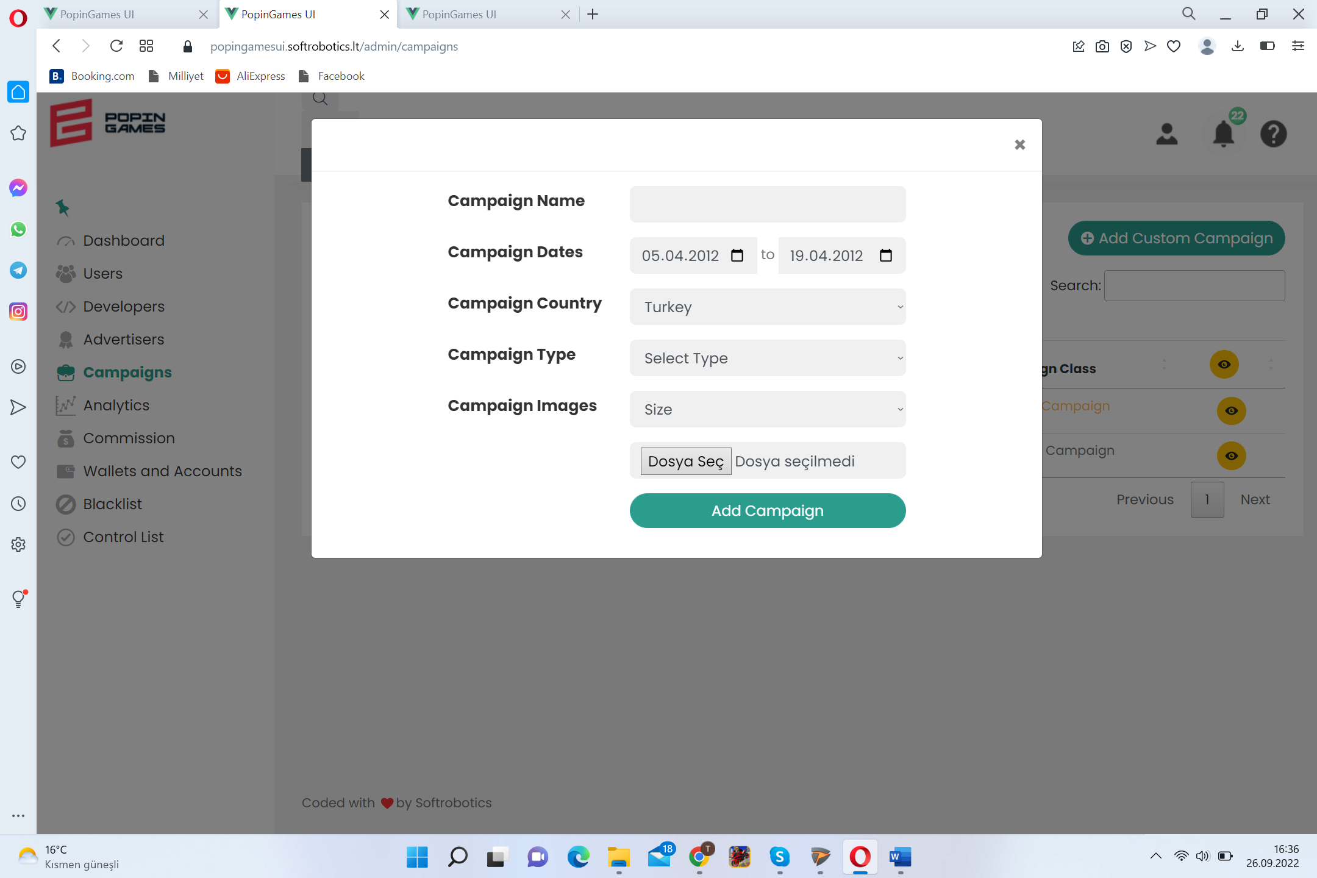 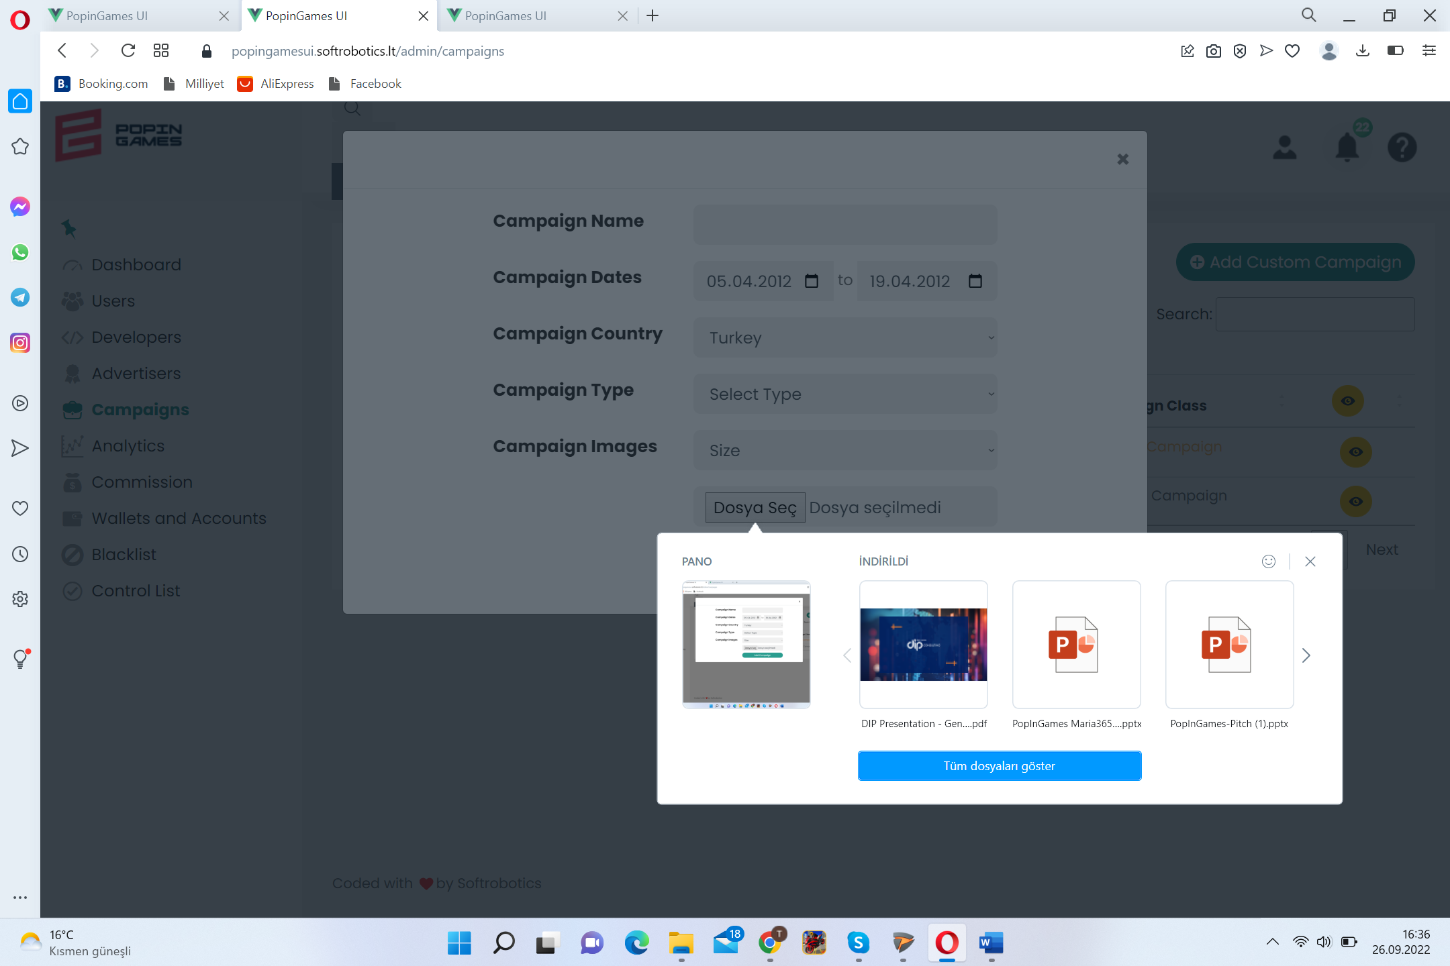

<https://popingamesui.softrobotics.lt/admin/analytics>

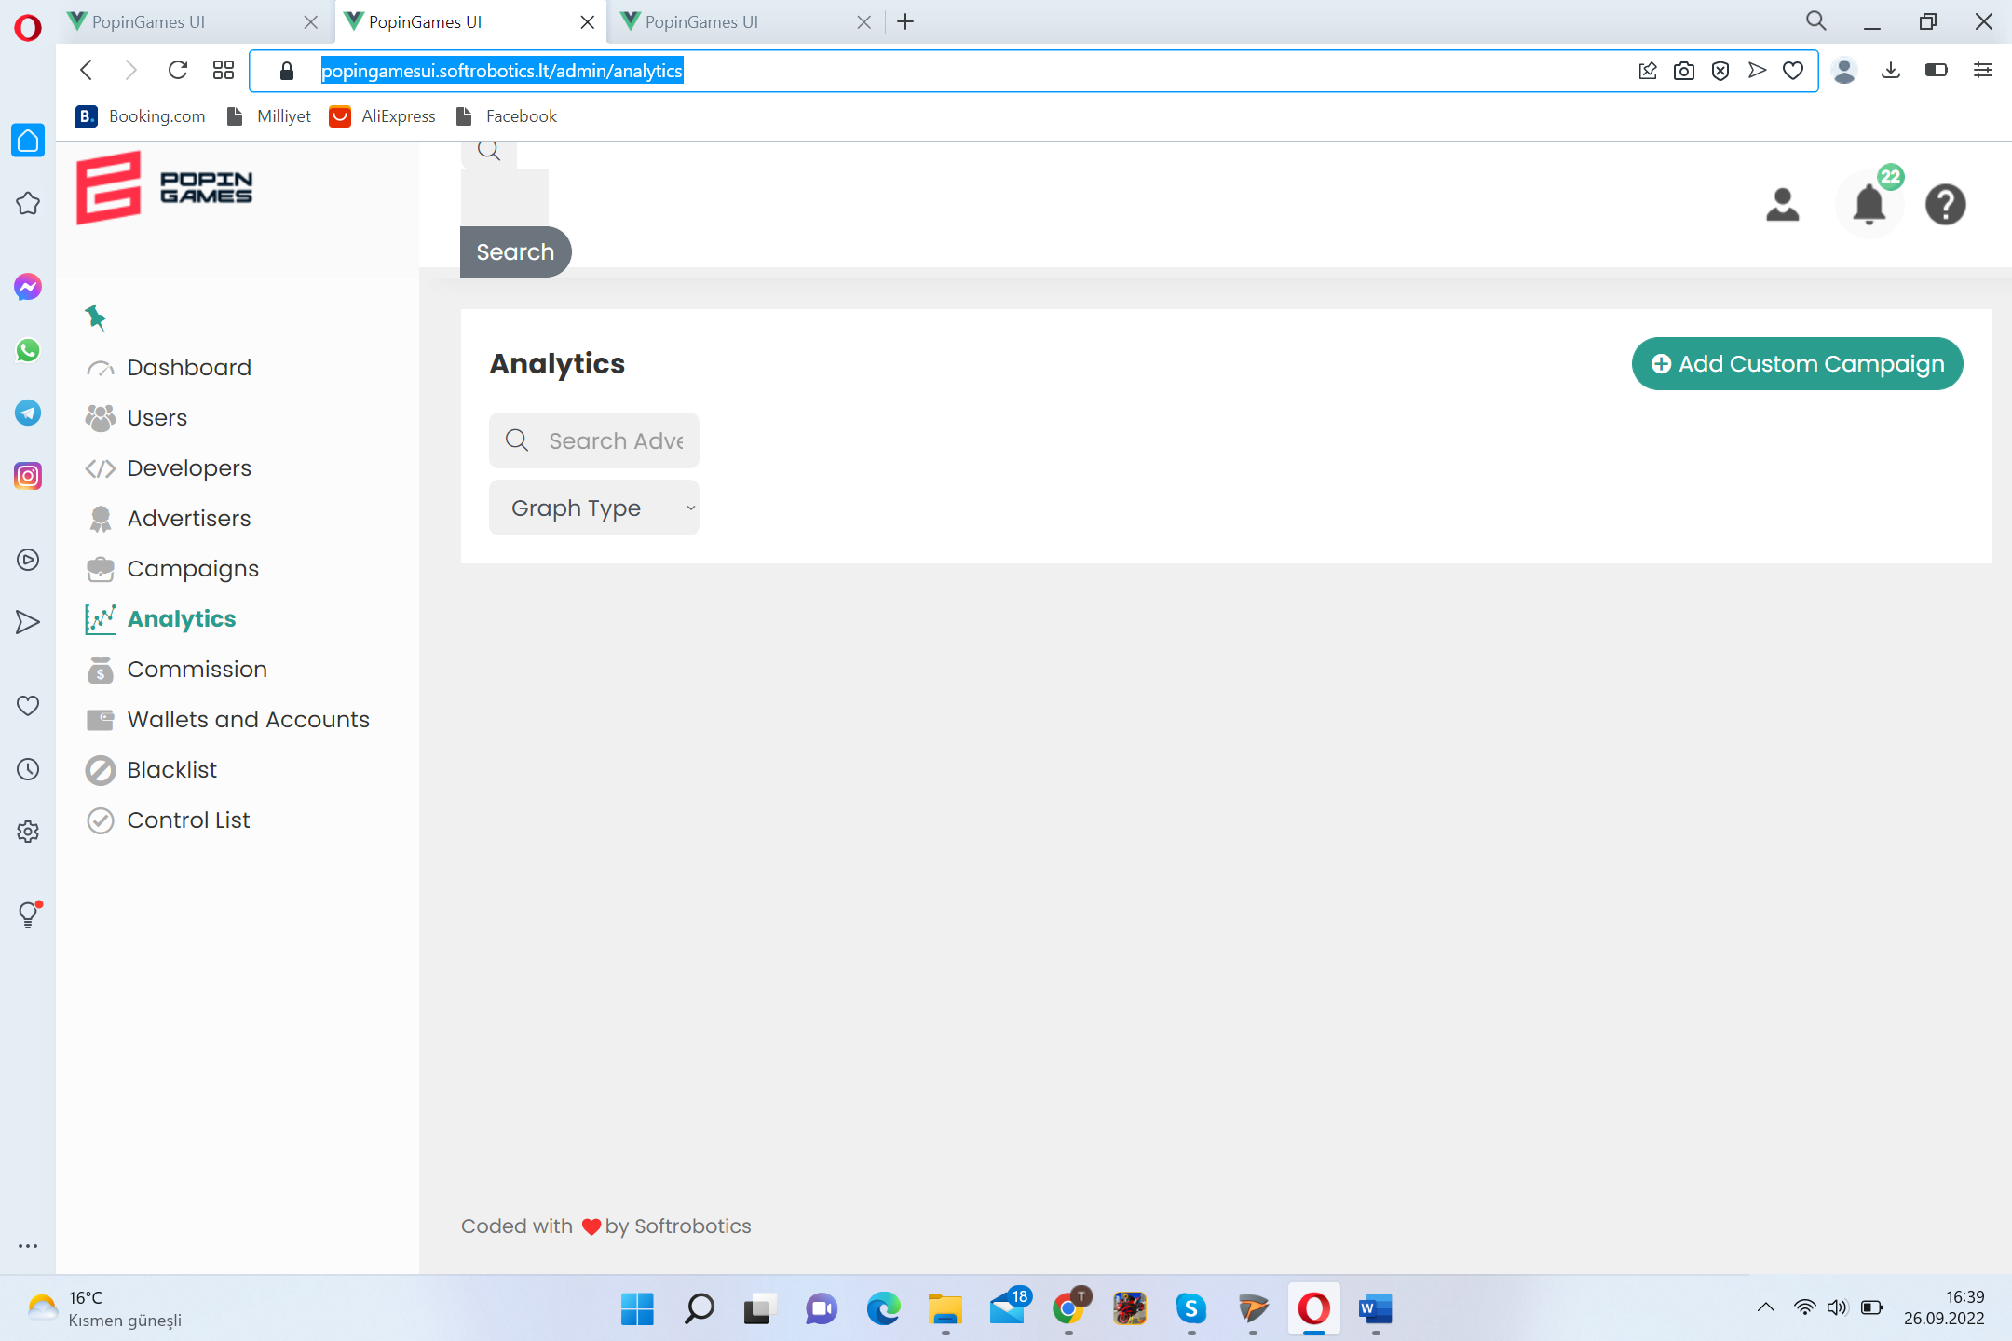

<https://popingamesui.softrobotics.lt/admin/commission>

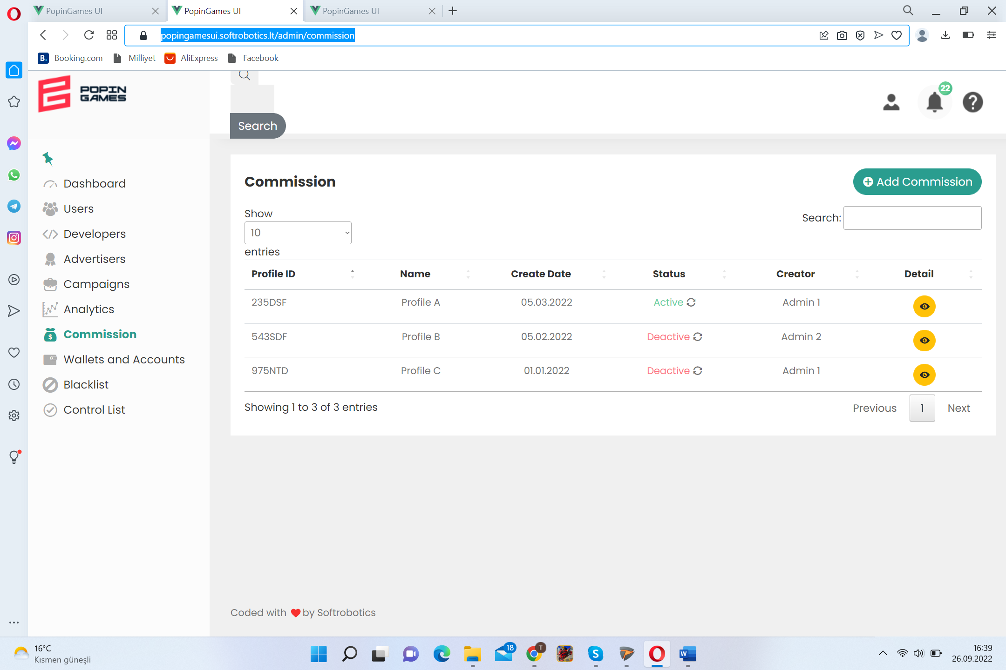 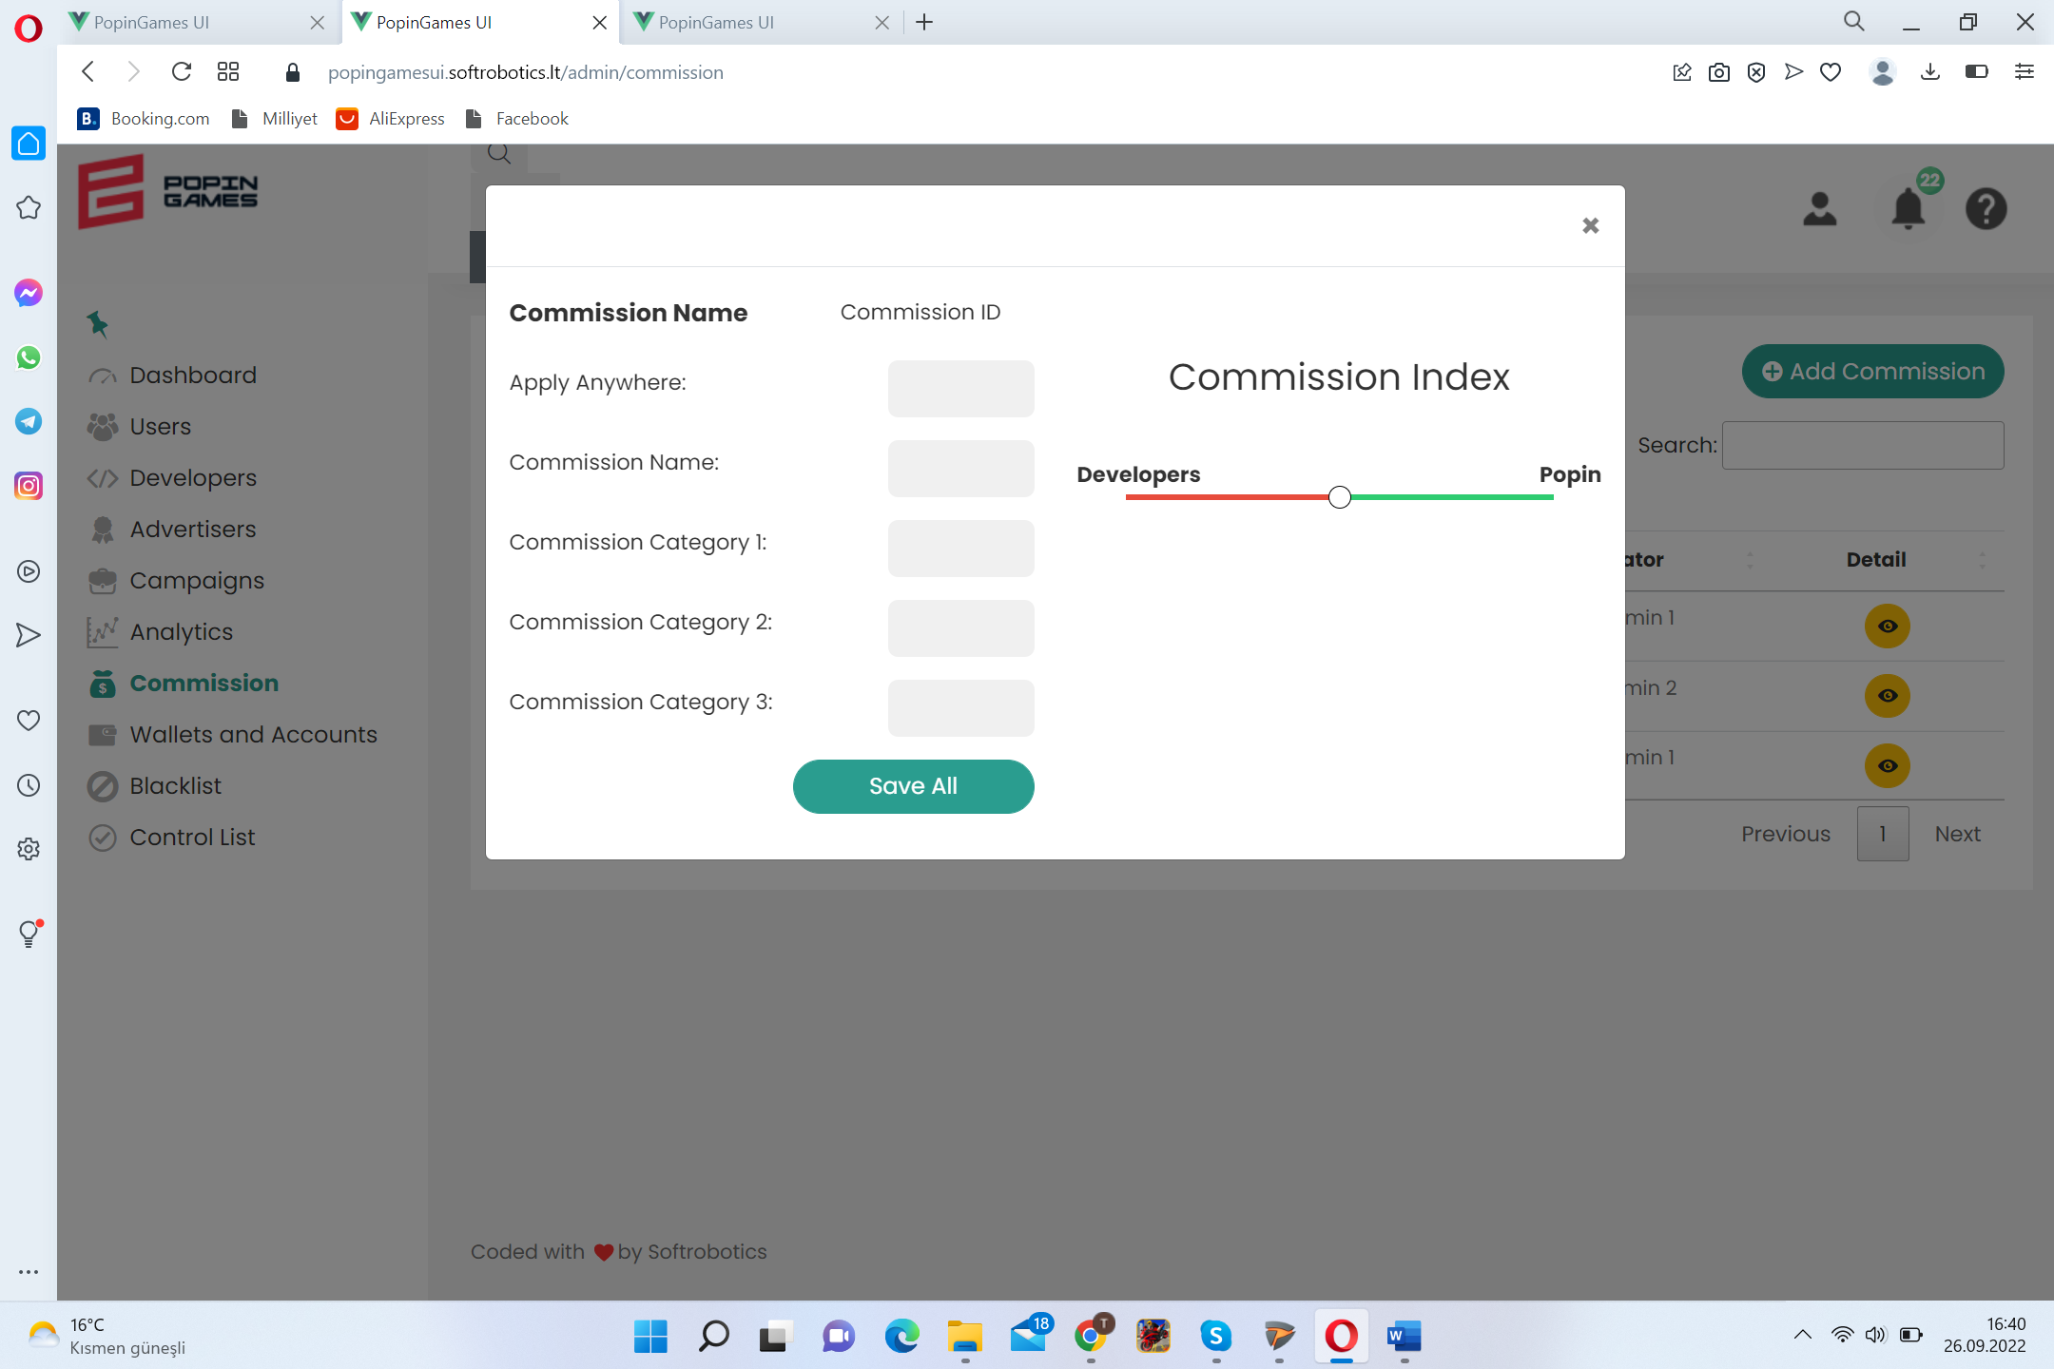

<https://popingamesui.softrobotics.lt/admin/wallets-and-accounts>

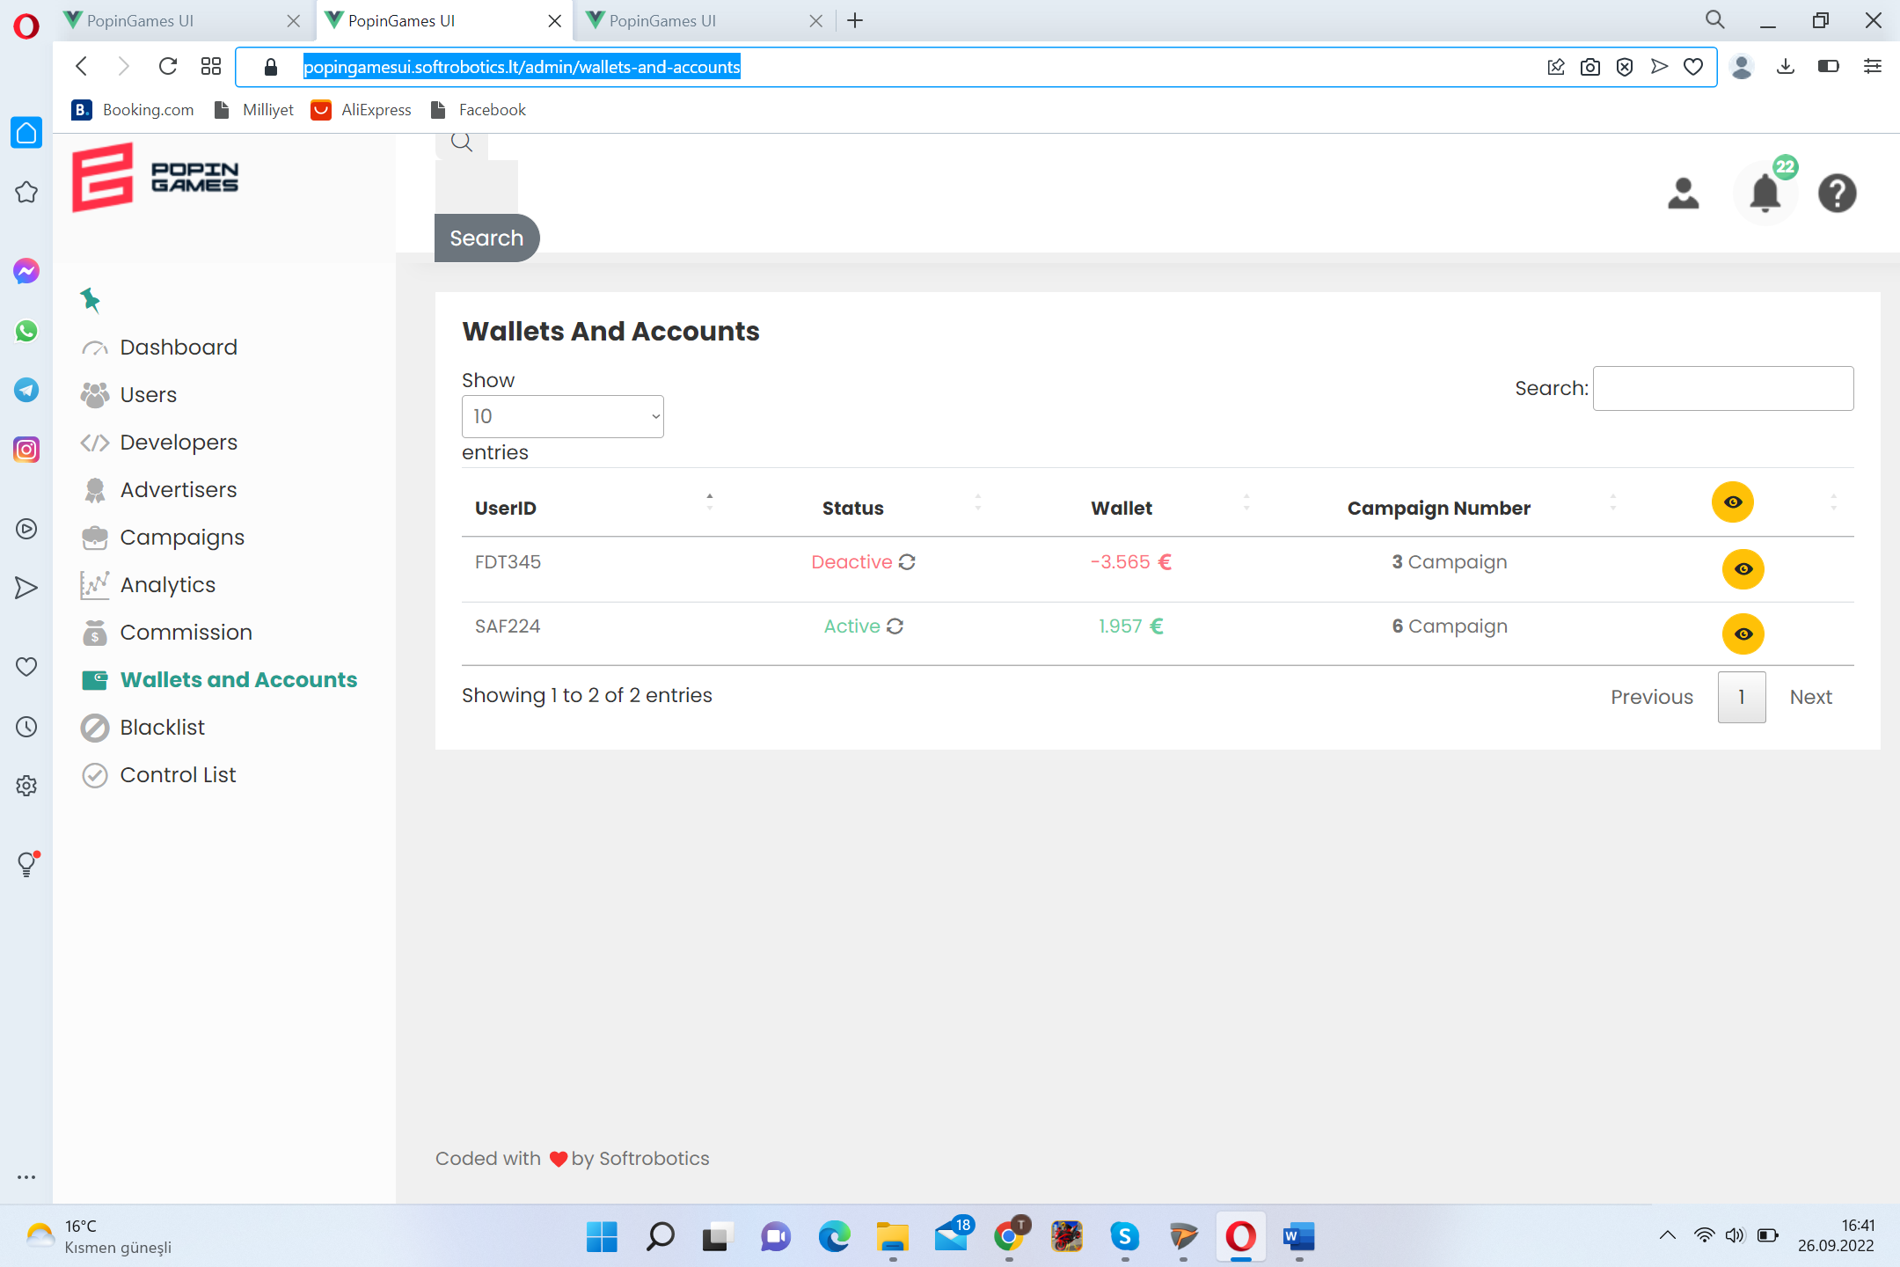 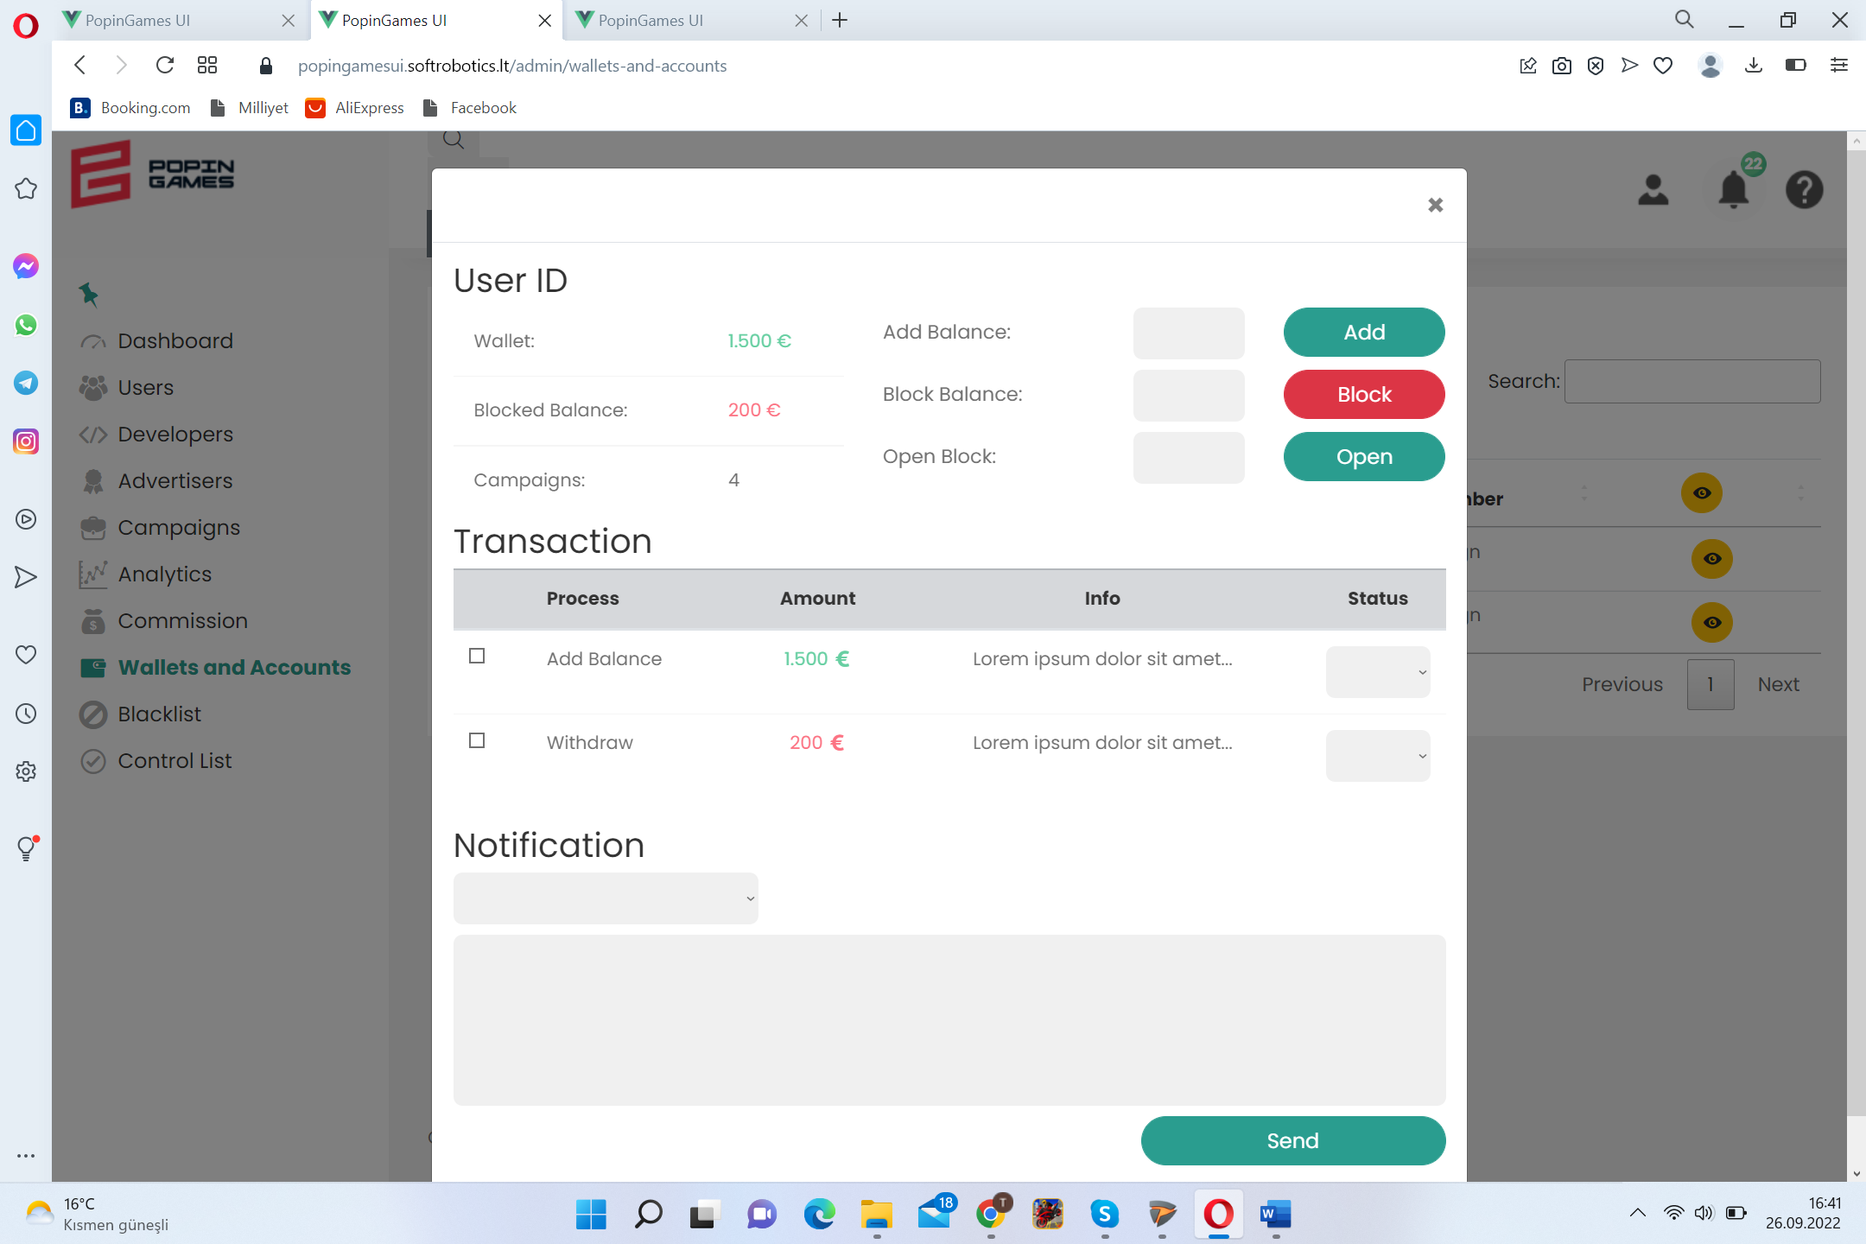

<https://popingamesui.softrobotics.lt/admin/blacklist>

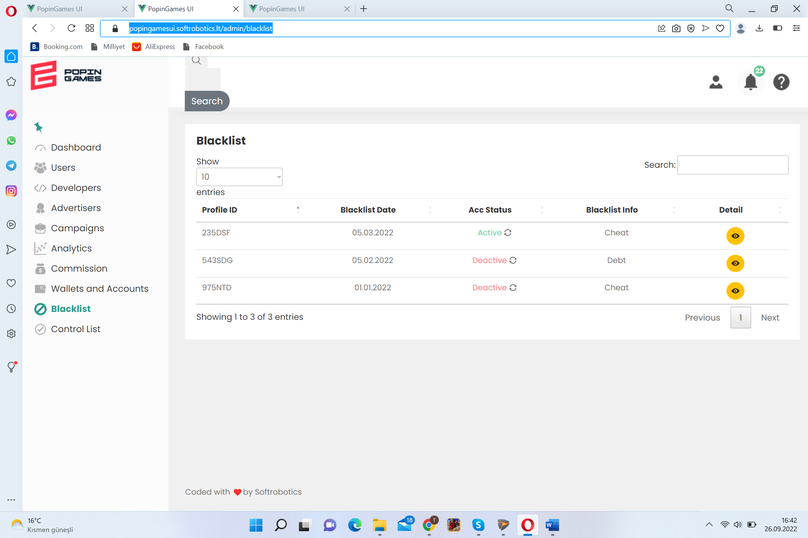 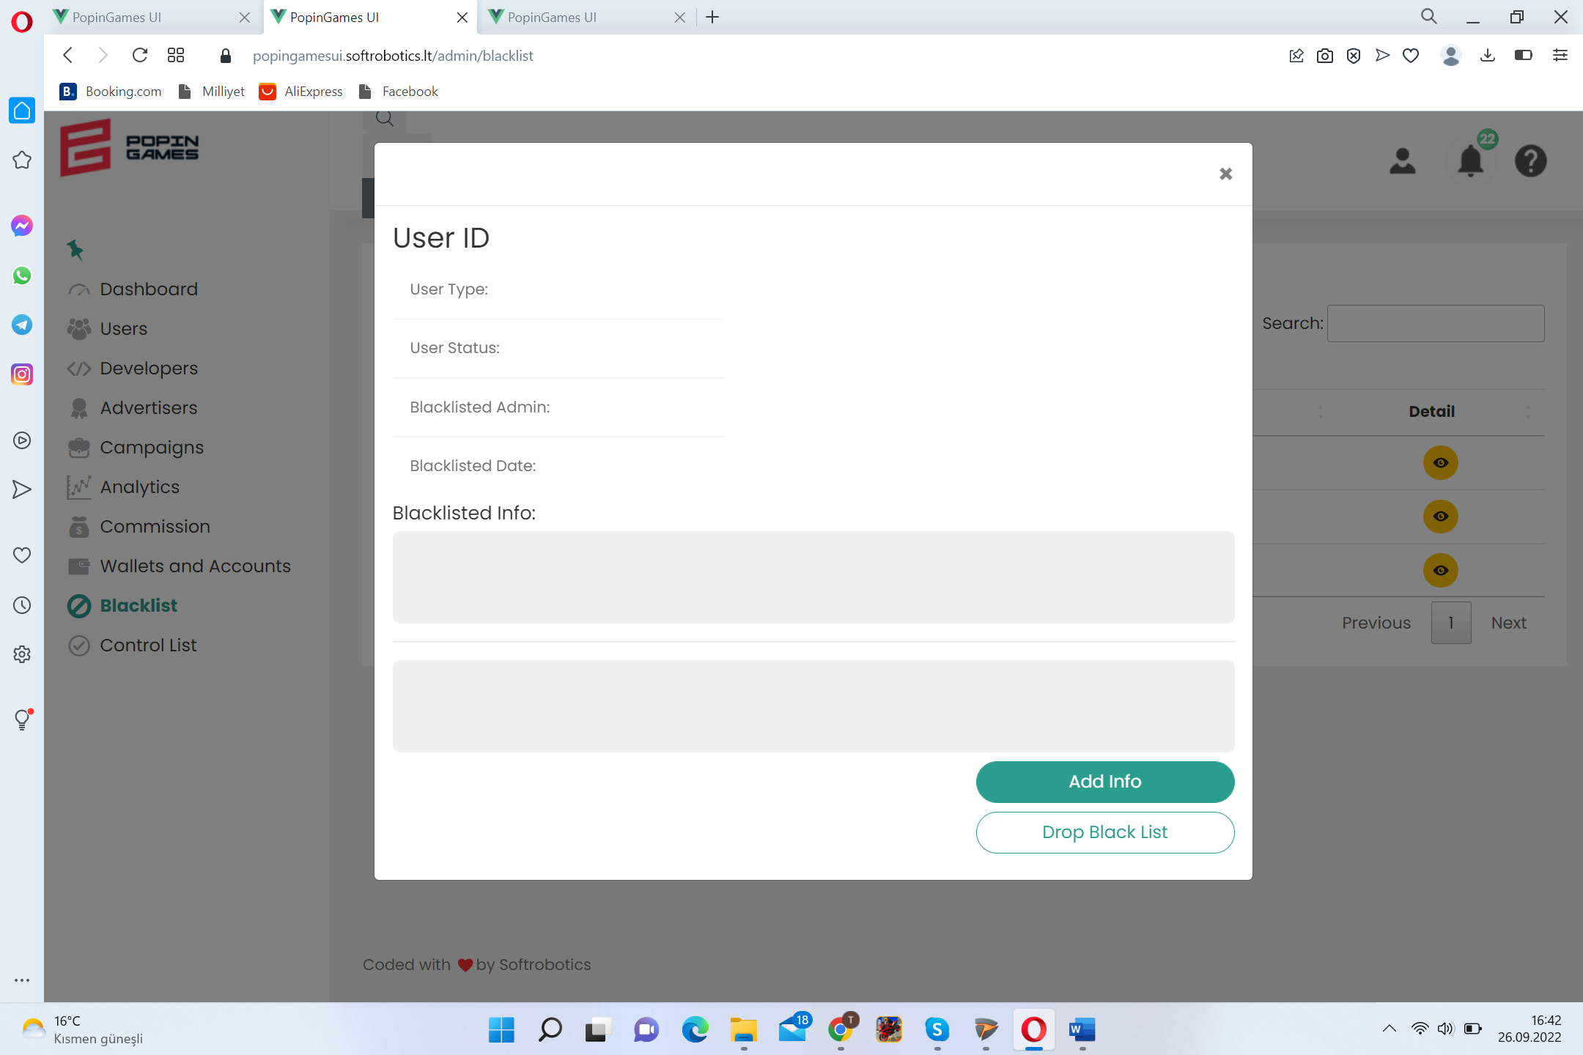

<https://popingamesui.softrobotics.lt/admin/control-list>

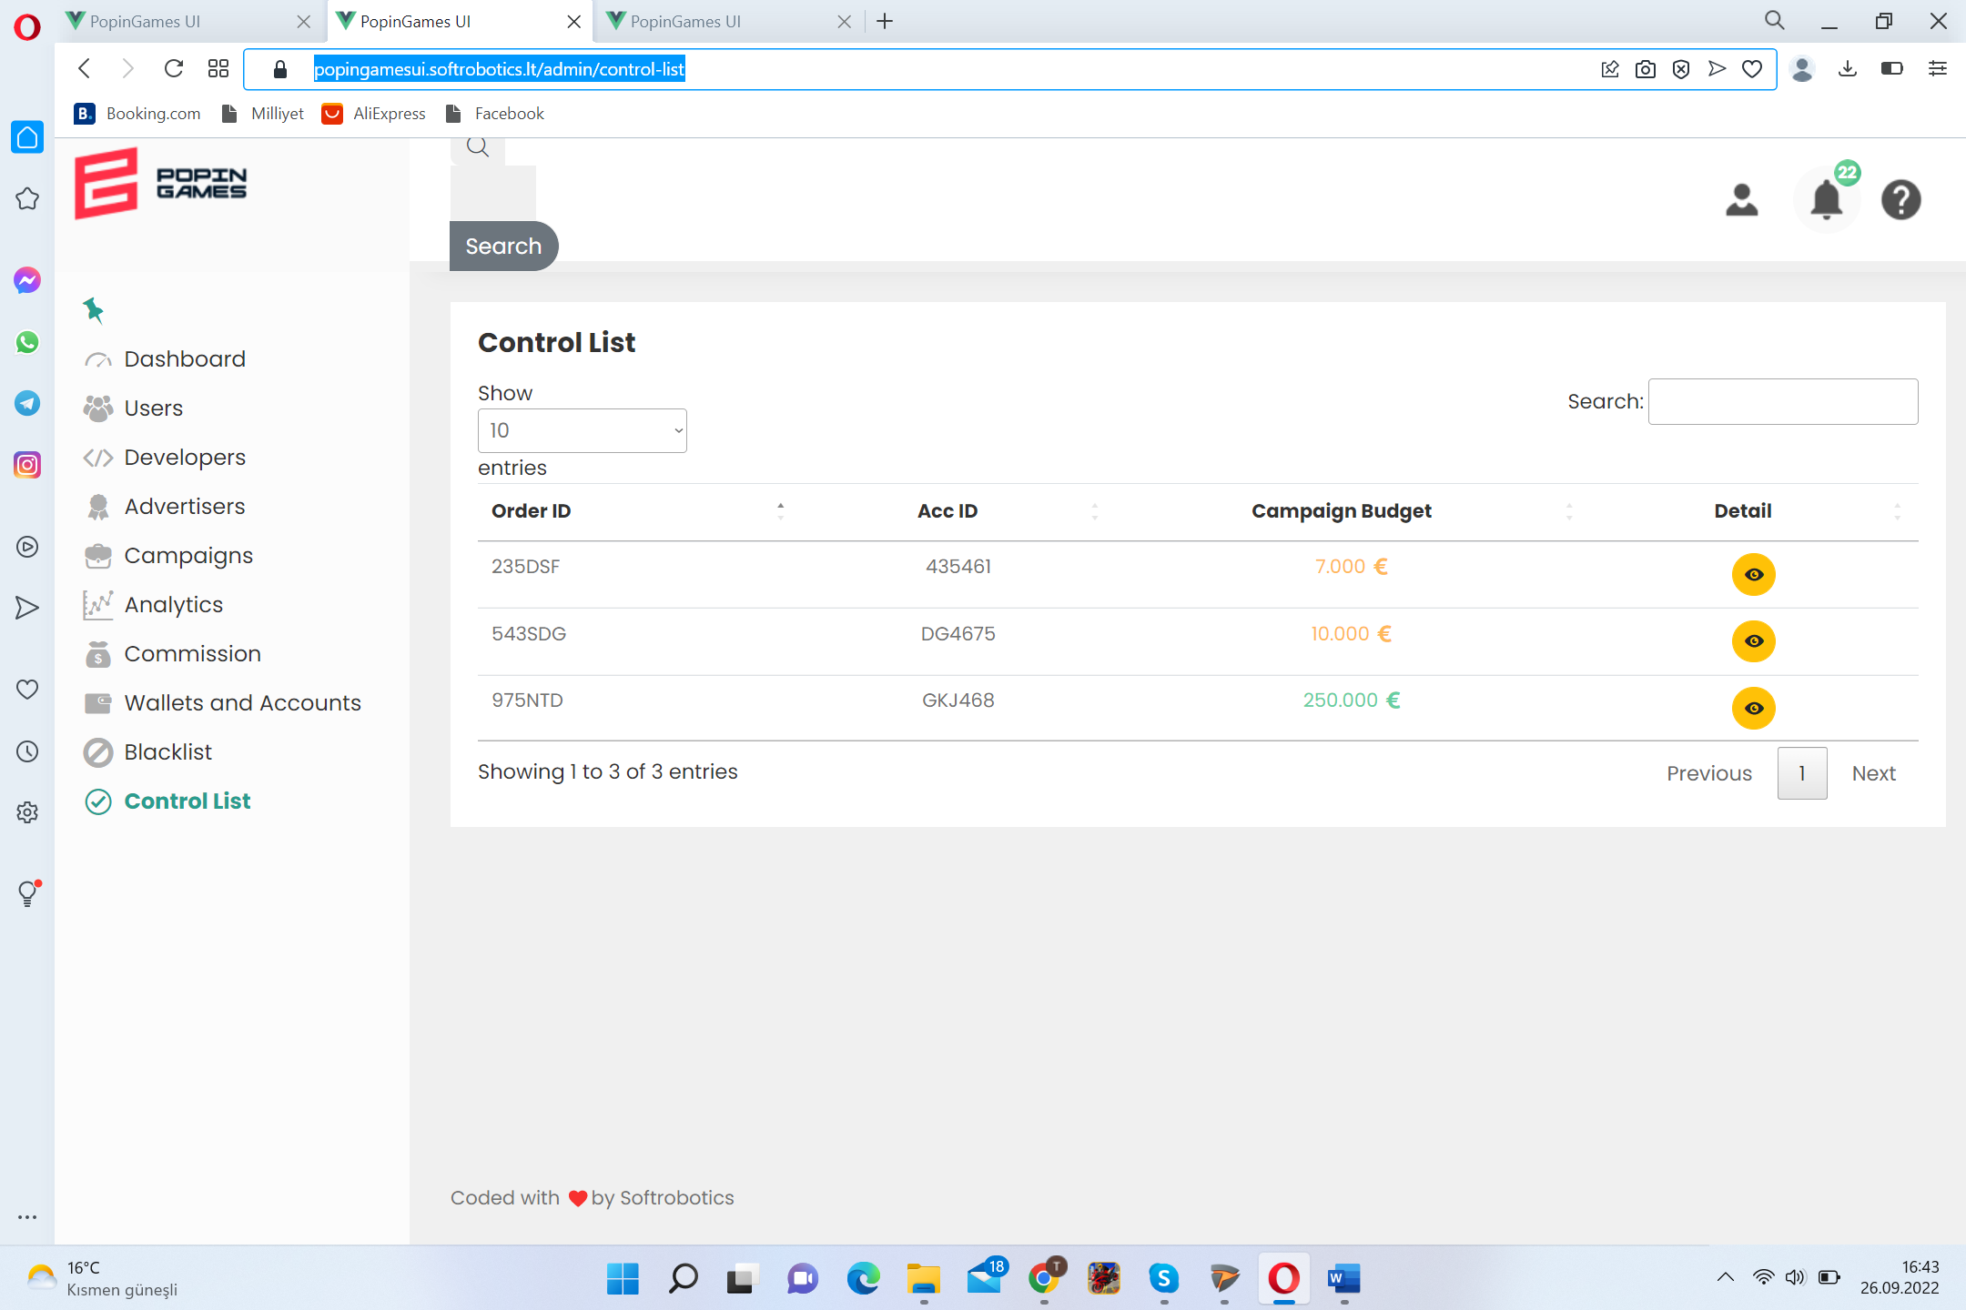 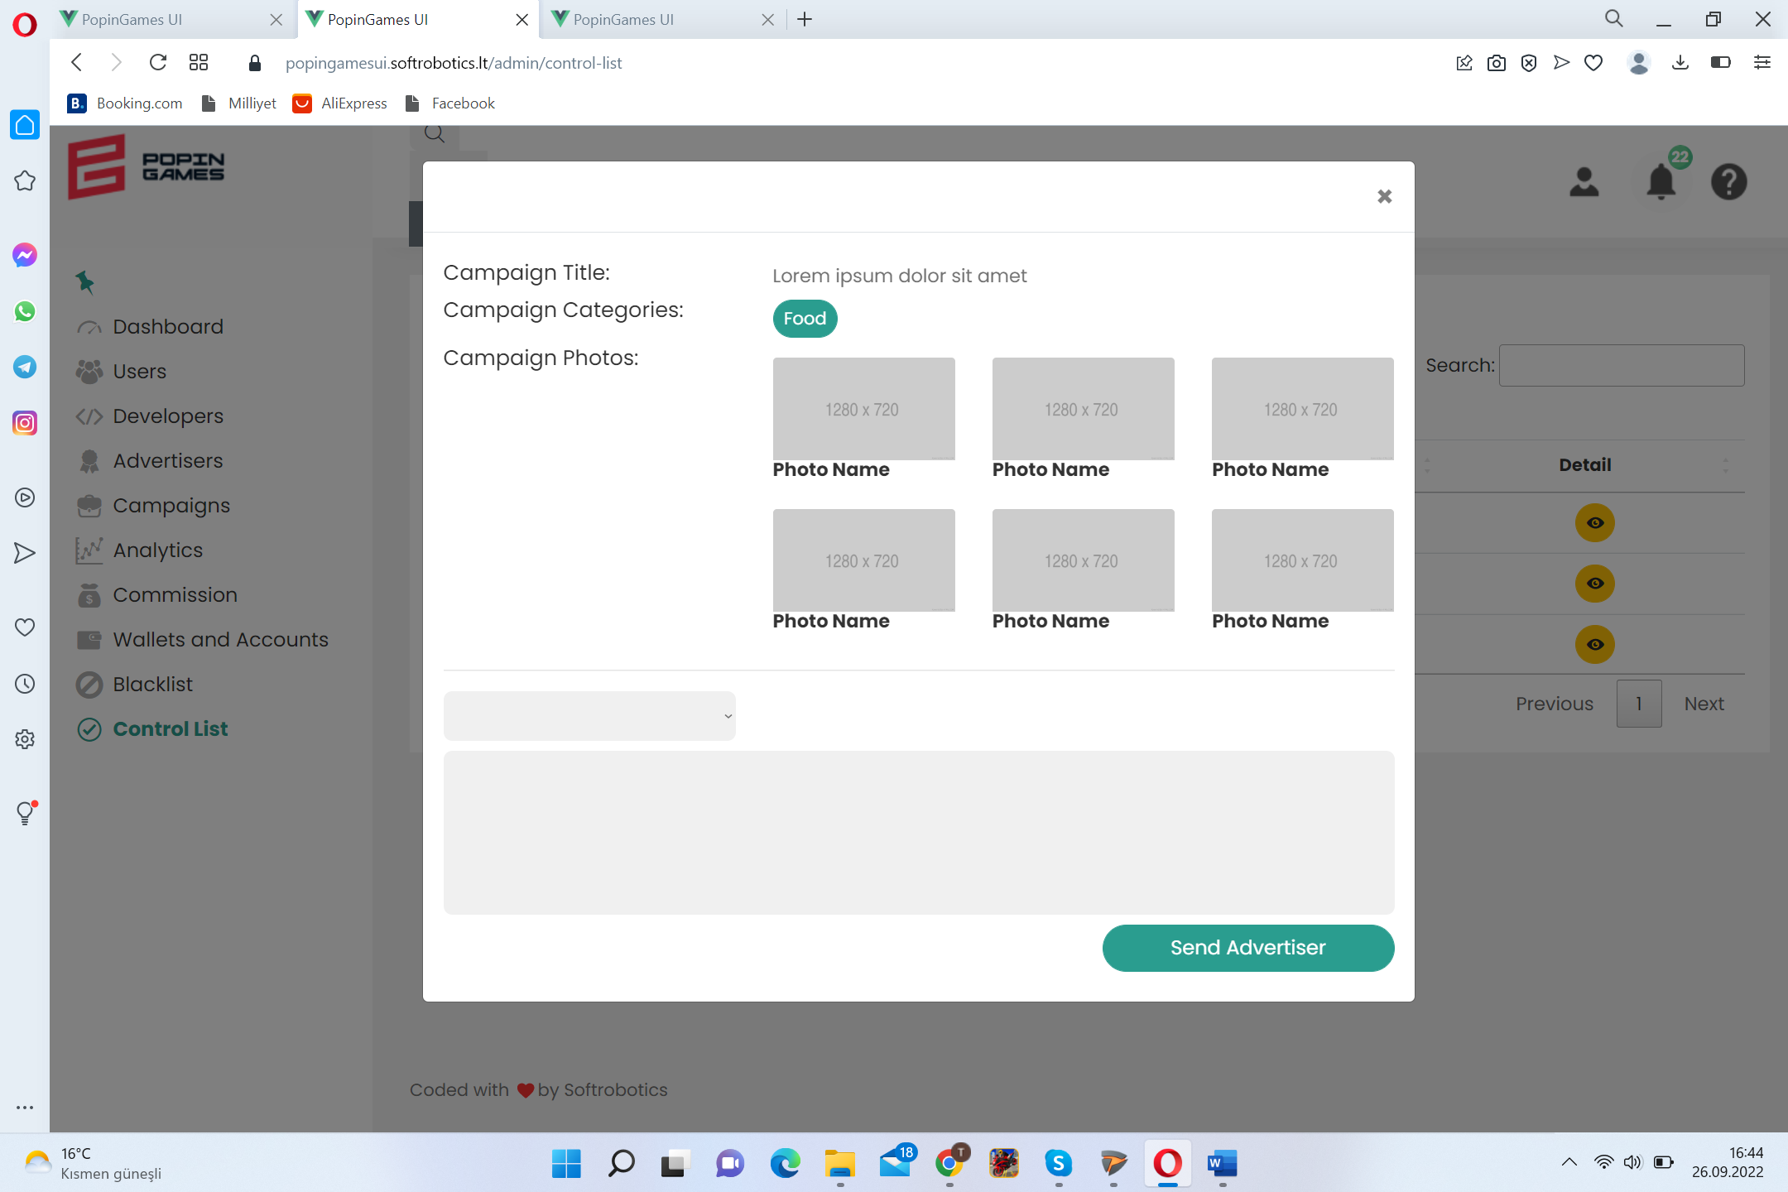

FLOW CHARTS

